AI 900

Contents

AZURE MACHINE LEARNING WORKSPACE 3

CREATING AZURE MACHINE LEARNING WORKSPACE 3

WORKING WITH ML WORKSPACE 5

BUILDING CLASSIFICATION ML PIPELINE 6

STEP 1: SPLIT DATA 7

STEP 2: TRAIN MODEL 13

STEP 3: SCORE MODEL 15

STEP 4: EVALUATE MODEL 16

STEP 5: RUN THE PIPELINE – EXPERIMENT 16

EVALUATION OF MODEL RESULT 16

DEPLOYING THE ML MODEL 18

INFERENCE PIPELINE 19

TESTING THE MODEL 26

CONSUMING MODEL USING ENDPOINT 26

AZURE AI VISION SERVICE 28

CREATING AI VISION SERVICE 29

VISION STUDIO 30

FEATURE - EXTRACT COMMON TAGS FROM IMAGES 31

FEATURE – ADD CAPTION TO IMAGES 33

FEATURE – OBJECT DETECTION 34

FEATURE – OPTICAL CHARACTER RECOGNITION 36

API CALL TO VISION SERVICE – POSTMAN 36

CUSTOM VISION SERVICE 39

SETTING UP CUSTOM VISION SERVICE 40

CREATING A CUSTOM VISION SERVICE 40

CUSTOM VISION PORTAL 42

FACE SERVICE 47

CREATING FACE API SERVICE 47

CALLING FACE API SERVICE USING POSTMAN 50

OTHER FACE API FEATURES 53

AZURE AI DOCUMENT INTELLIGENCE SERVICE 53

CREATING A DOCUMENT INTERLLIGENCE SERVICE 54

DOCUMENT INTELLIGENCE STUDIO 55

AZURE AI FOUNDRY 56

NATURAL LANGUAGE PROCESSING 56

SERVICES FOR NLP IN AZURE 56

AZURE LANGUAGE SERVICE 57

CREATING LANGUAGE SERVICE 58

KEY FEATURES 60

KEY PHRASE EXTRACTION 60

AZURE TRANSLATOR SERVICE 60

AZURE SPEECH SERVICE 60

AZURE FOUNDRY 61

CREATE AZURE AI HUB 61

COURSE RESOURCES AND SET UP 63

# AZURE MACHINE LEARNING WORKSPACE

* To work on ML in Azure we need to deploy Azure ML workspace.

## CREATING AZURE MACHINE LEARNING WORKSPACE

* The Azure ML workspace encapsulates the ML artifacts that include datasets, ML models etc.
* When we deploy ML workspace, there are other resources also get deployed along with it

|  |  |  |  |  |  |  |  |  |  |
| --- | --- | --- | --- | --- | --- | --- | --- | --- | --- |
|  | |  |  | | --- | --- | | **STORAGE ACCOUNT** | * When we run the Job to train the machine learning model, these storage accounts are used to store the logs | | **CONTAINER REGISTRY** | * Used to store the images of created docker container | | **KEY VAULT** | * To score secrets needed by workspace or other resources | | **APPLICATION INSIGHT** | * To collect diagnostic information from the inference endpoints | |

* Provide the name of ML workspace 🡪 Review & Create (*We will keep default selection of other options in the wizard*)

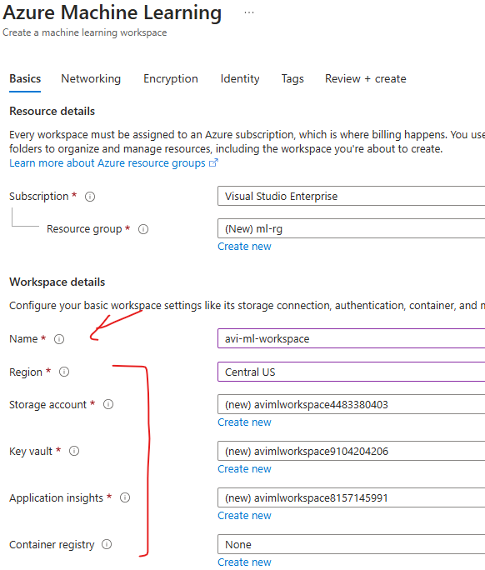

CREATED RESOURCES

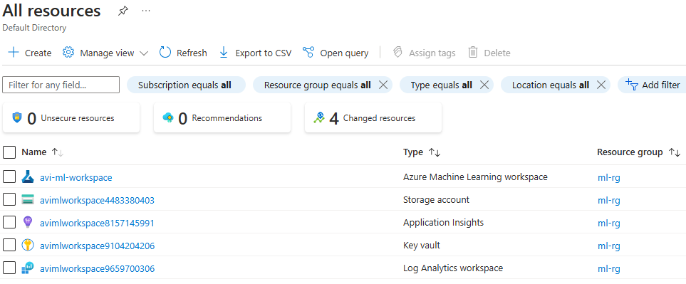

* The ML workspace is a separate interface, hence to launch the workspace 🡪 Click on Launch Studio

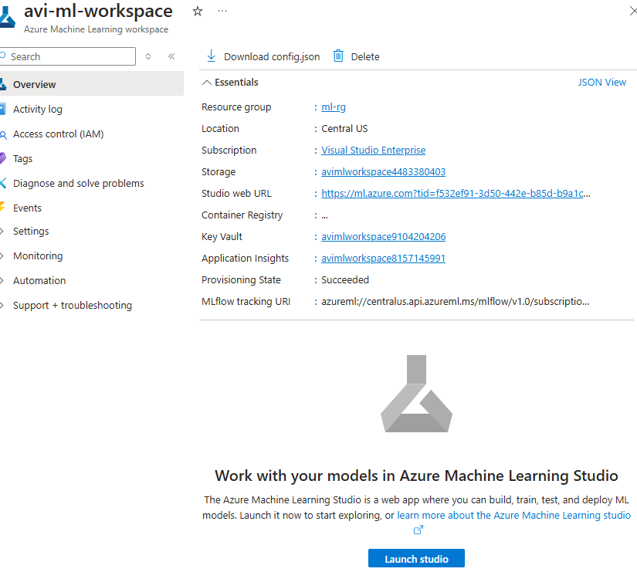

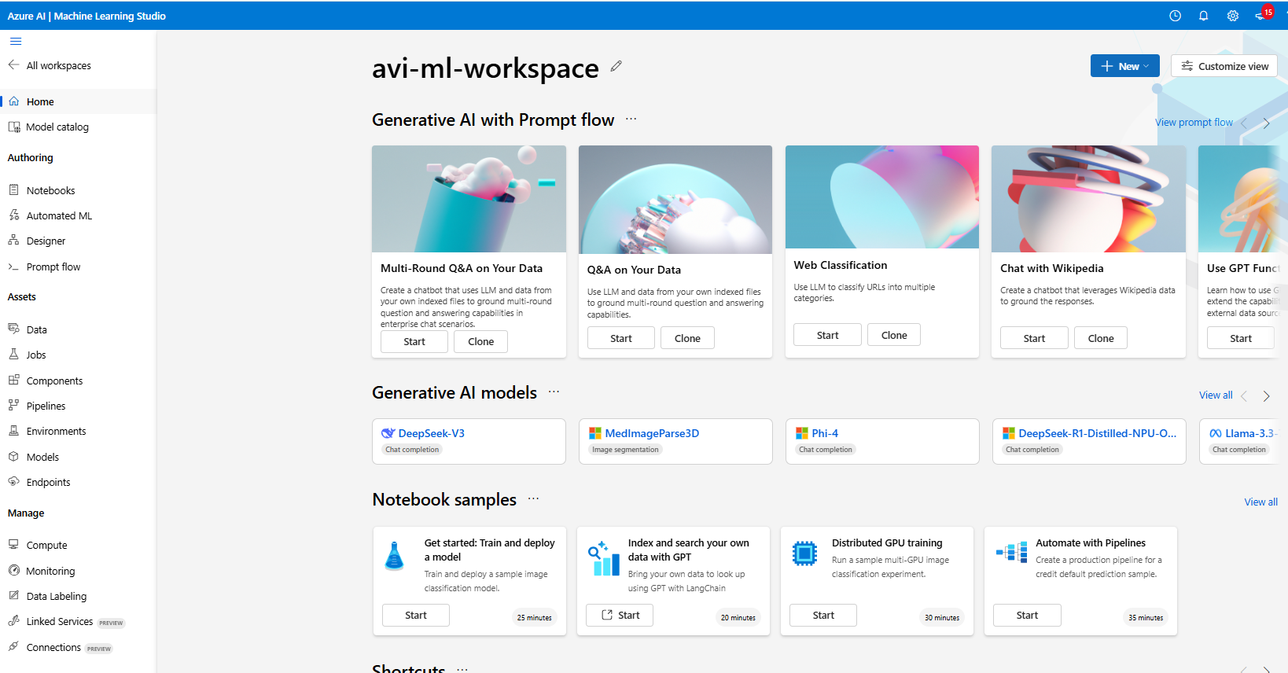

## WORKING WITH ML WORKSPACE

1. **AZURE ML DESIGNER**
   1. Once the workspace is set up, we can access Azure ML Designer, a visual interface within Azure ML that allows us to build machine learning pipelines using pre-built components.
   2. This eliminates the need for extensive coding or development.
2. **CREATING A NEW PIPELINE**
   1. In Azure ML Designer, we can create a new pipeline to start building machine learning model.
   2. A pipeline in Azure ML is a series of connected components that define the workflow and operations performed on the data.
3. **USING PRE-BUILT COMPONENTS**
   1. Azure ML Designer provides a set of pre-built components that can be used in the pipeline.
   2. These components represent specific tasks or operations, such as data ingestion, data preprocessing, feature extraction, model training, and evaluation.
   3. We can choose from a variety of components based on specific requirements.
4. **DRAGGING COMPONENTS ONTO THE CANVAS**
   1. In the Azure ML Designer canvas, we can drag and drop the pre-built components onto the canvas to build the model pipeline.
   2. Components can be connected to define the flow of data and the sequence of operations.
5. **CONFIGURING AND CONNECTING COMPONENTS**:
   1. After placing the components on the canvas, we can configure their properties and connect them to define the data flow and processing steps.
   2. This includes specifying input and output connections, setting parameters, and adjusting component settings.

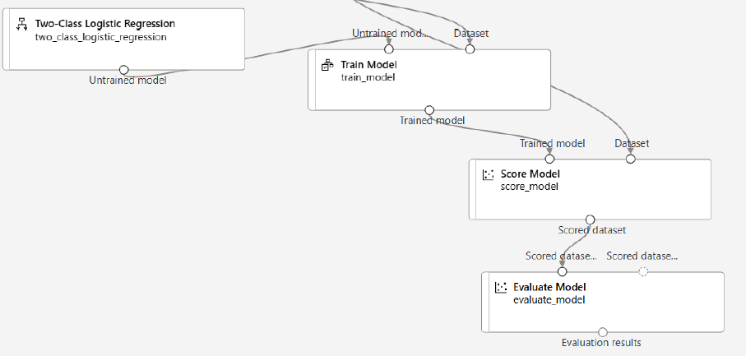

1. **TRAINING AND BUILDING THE MODEL**:
   1. Once the pipeline is set up, we can start the training and building process. This involves providing the necessary data to the pipeline and executing the components in the desired sequence.
   2. Data flows through the pipeline, and each component performs its assigned task, such as data transformation, model training, or model evaluation.
2. **MONITORING AND ITERATING**:
   1. Azure ML provides monitoring capabilities to track the progress and performance of the pipeline.
   2. We can monitor metrics, logs, and outputs to assess the model's performance and iterate on the pipeline configuration if necessary.

## BUILDING CLASSIFICATION ML PIPELINE

* The classification model is used to predict the values that fall in into simple category.
* In the below example we will use a pre-built dataset to train the model (Azure ML workspace has multiple pre-built data set). We will be using “***adult_census_income_binary_classification***”. In real world scenario we need to get the data set from one or multiple sources and then clean the data, which can then be used to train the ML model.
* Based in the below dataset model give the prediction of income (label)(*Income has two categories >50k or <=50k*)

|  |
| --- |
| Our aim is to build a machine learning model. This model will be used to classify the income of individuals into 2 classes - <=50K or > 50K |

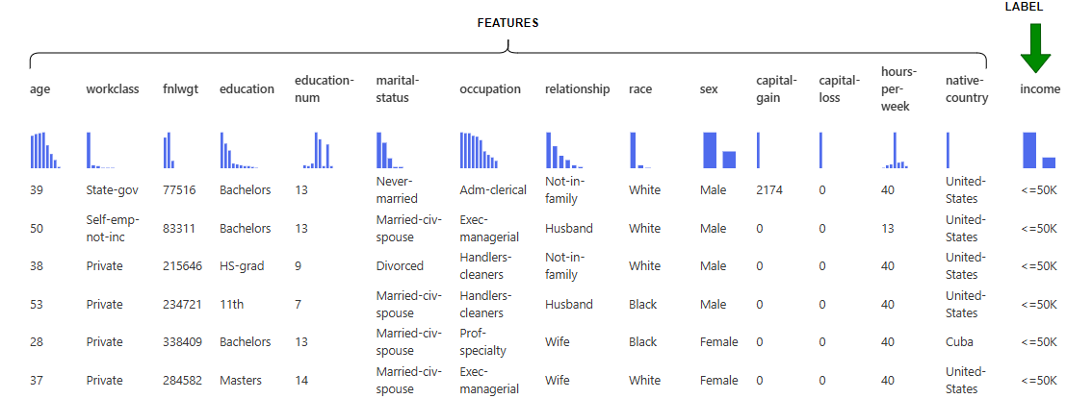

### STEP 1: SPLIT DATA

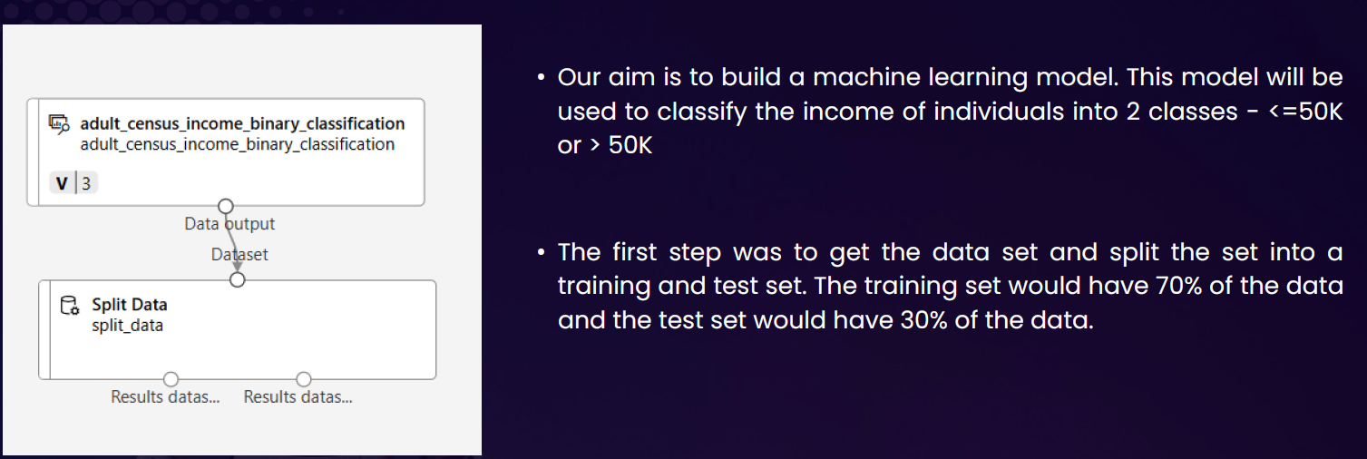

#### DATA SET

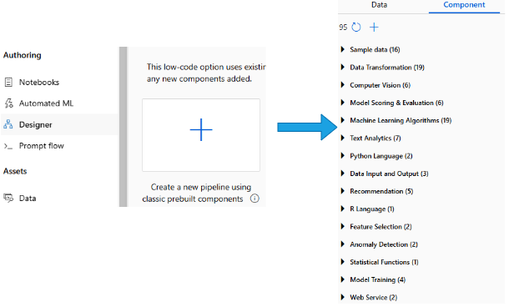

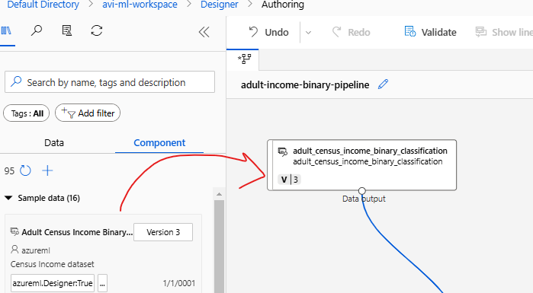

#### SPLIT DATA

|  |  |
| --- | --- |
|  | * The dataset is then further split in certain ratio e.g. 70% of data can be used to train the model and 30% for validation * For the drag & drop the “Split data” component and configure the desired ratio of data split |

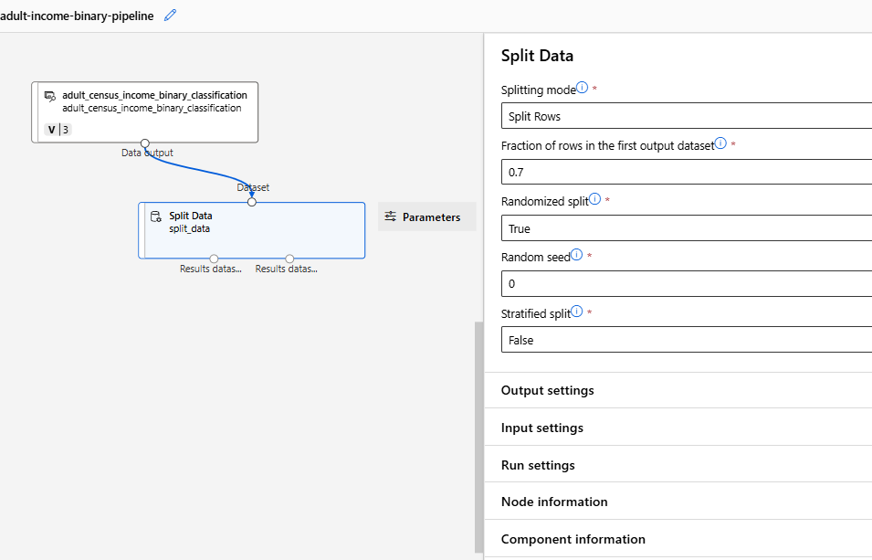

#### SETTING UP THE COMPUTE INSTANCE

|  |  |
| --- | --- |
|  | * To build/ train the ML model, we need to run the pipeline. * To execute the pipeline, we need a compute instance where the pipeline will execute. The compute instance is a Azure VM under the hood * Note: The ML algorithm is set of instructions / code. This instruction must iterate through large datasets to look at the pattern in the data. Hence, it needs a compute machine to run the instruction and build the ML model |

* The compute instance VM are available in different SKUs. For the below example- we will select ***Standard_DS3_v2*** VM
* For this example - we will keep other options as default and create the VM

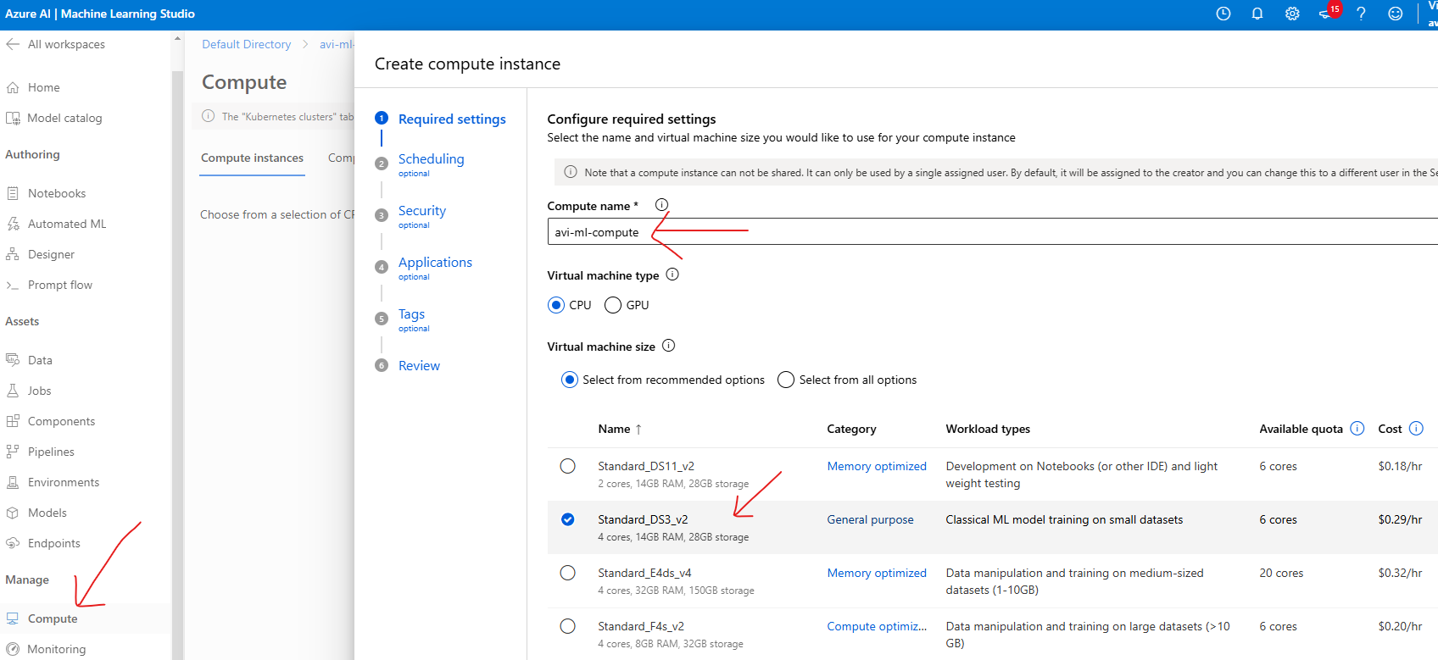

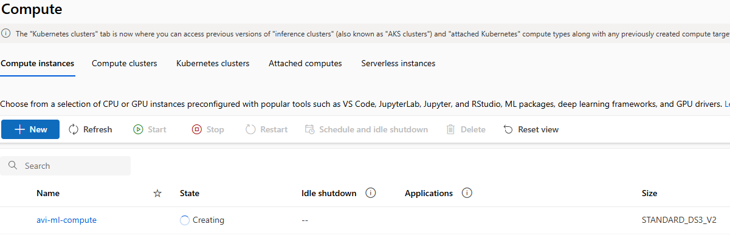

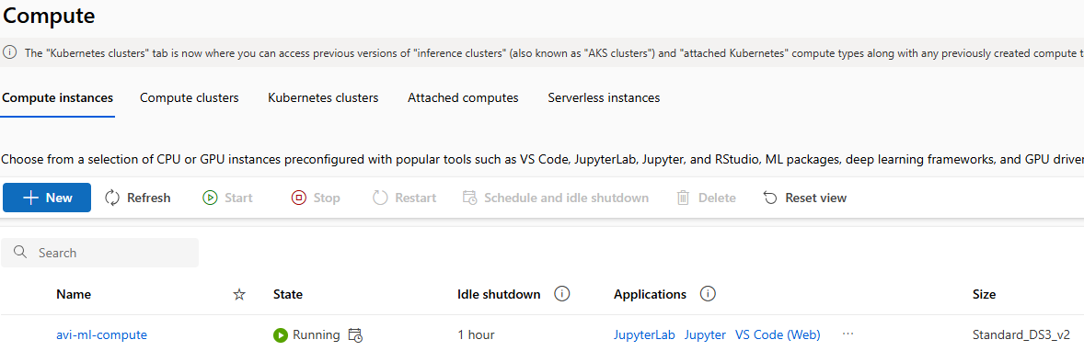

#### RUNNING THE PIPELINE

* After the compute instance is setup, we can now run the pipeline (Note – the pipeline is not yet complete)
* To run the pipeline, we need to create an experiment
* The execution aka experiment will create a Job. This Job will execute on the compute machine
* Go to Designer 🡪 Configure & Submit

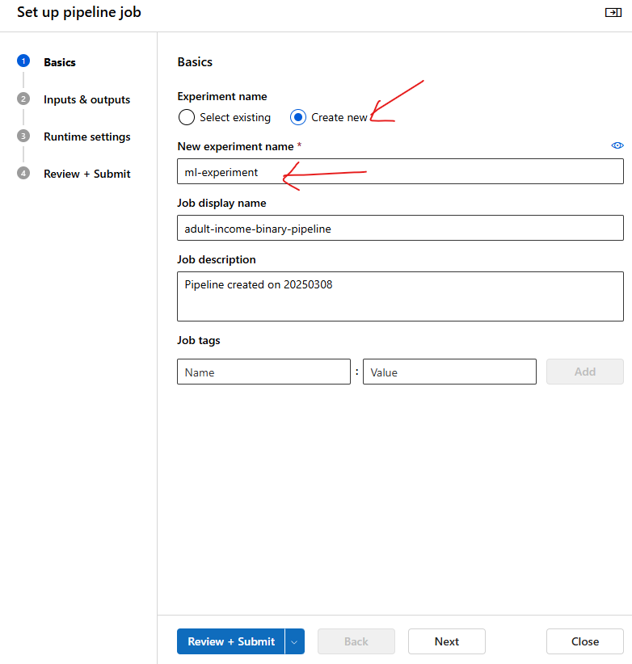

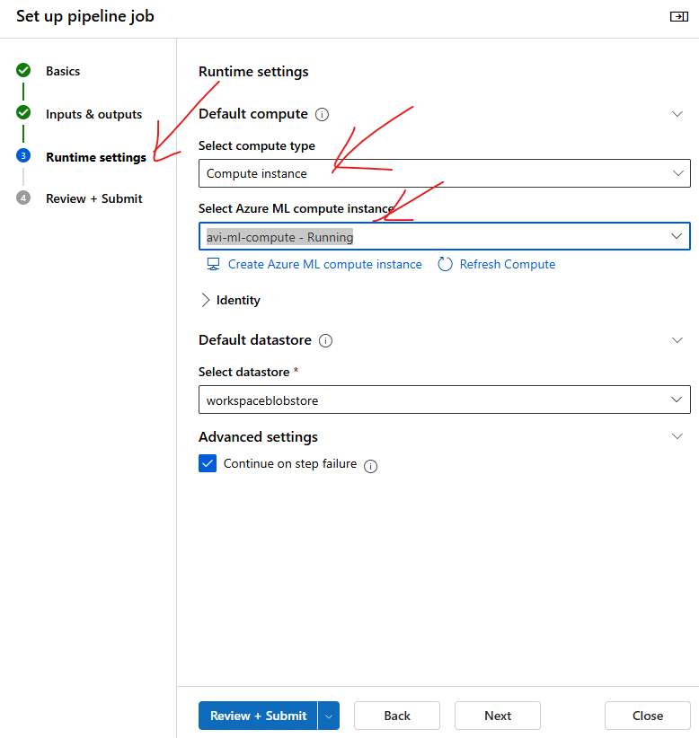

* The Job will download the entire dataset in the compute machine and then split the data

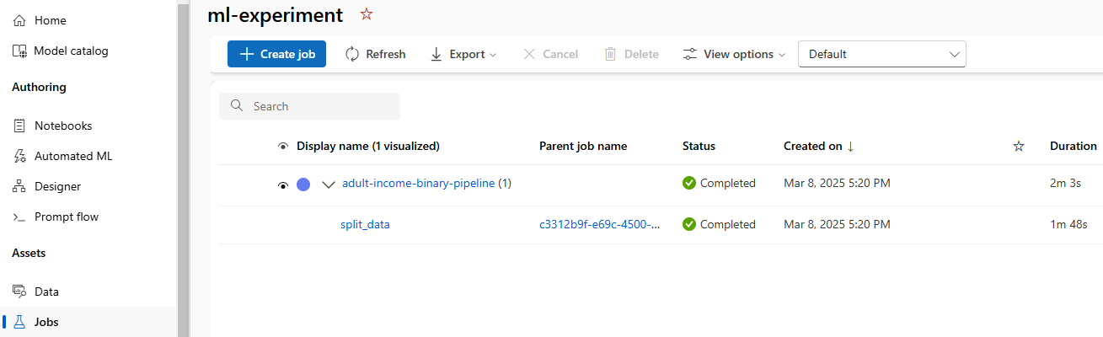

* The split data component will split the data in to 2 datasets in 70-30 ratio.

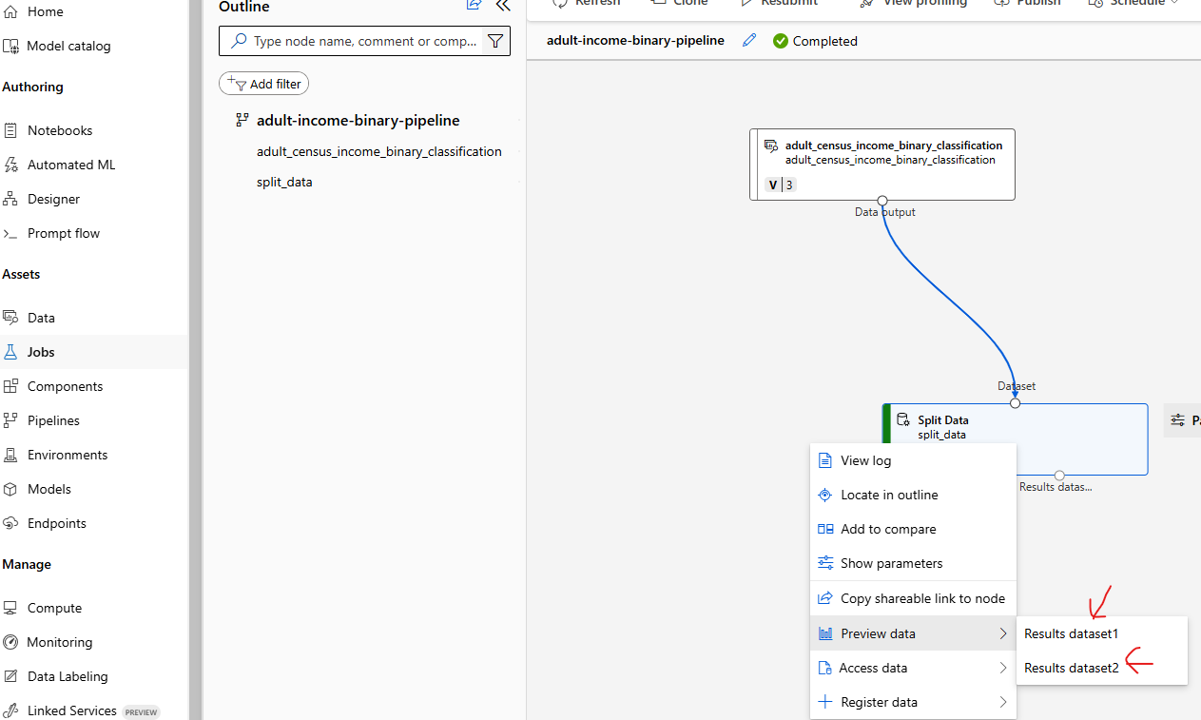

### STEP 2: TRAIN MODEL

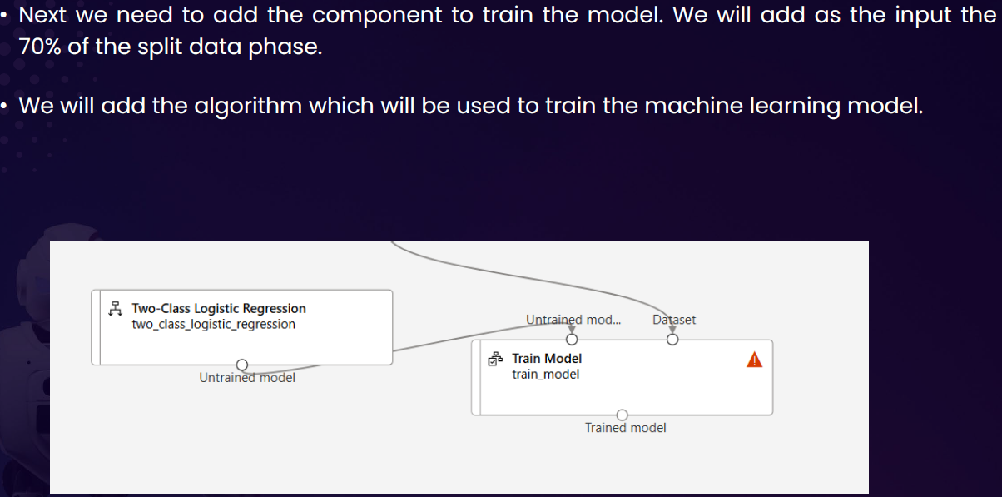

#### CONFIGURE THE LABEL

To configure the model

* Click on Pipeline Interface 🡪 Train Model Component 🡪 Edit Column

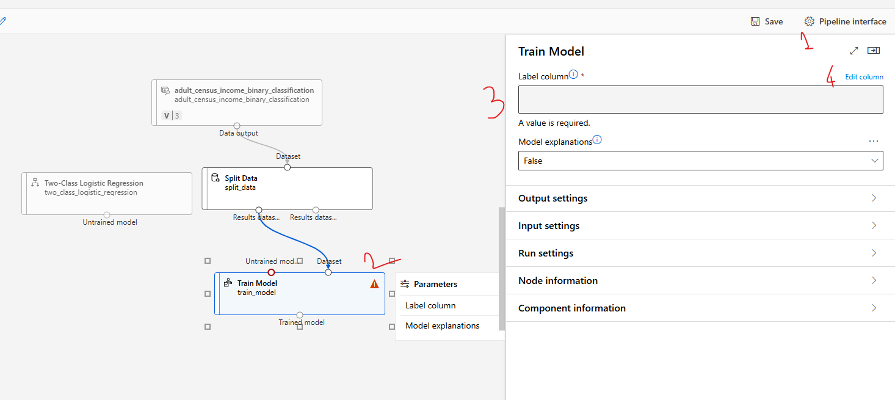

* Provide the name of the column name of the “**Label**” 🡪 Save

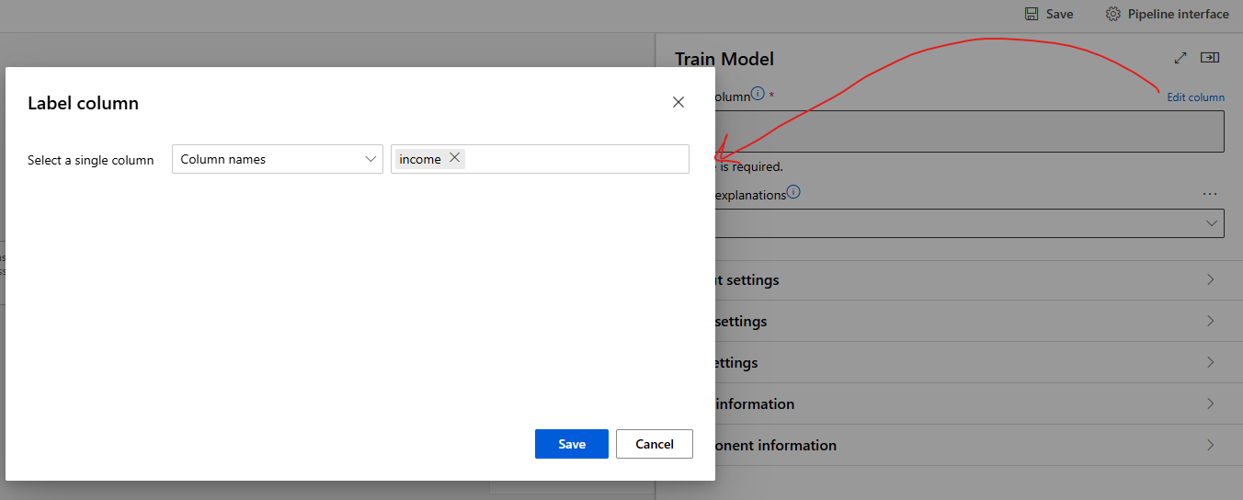

#### CONFIGURE THE ALGORITHM

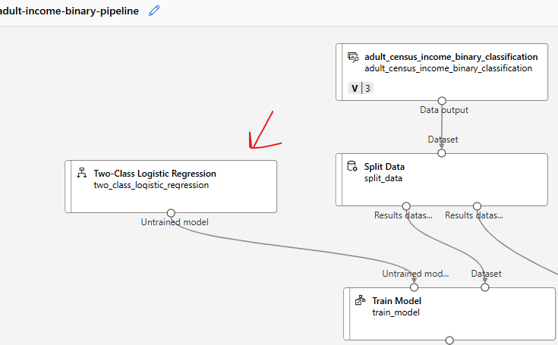

### STEP 3: SCORE MODEL

* Score model is to test the model performance. For that we need to feed the 30% of the test data and Model as an input

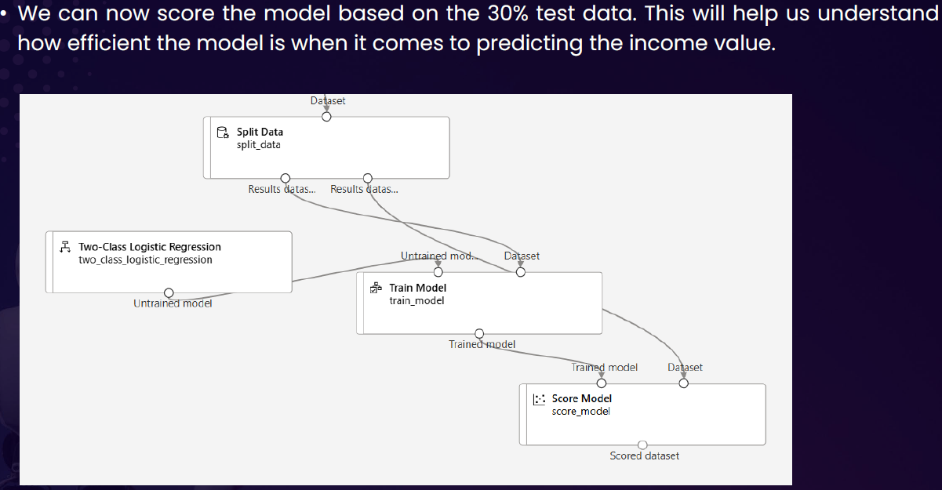

### STEP 4: EVALUATE MODEL

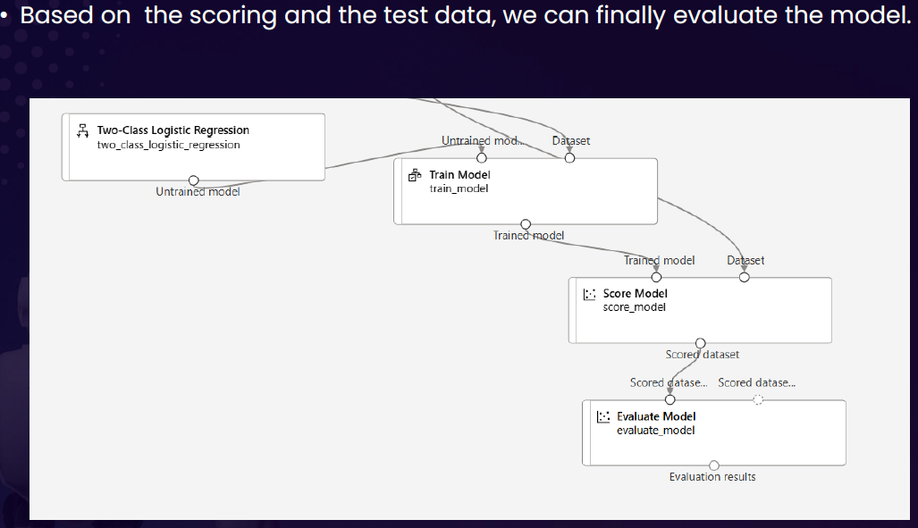

### STEP 5: RUN THE PIPELINE – EXPERIMENT

* Designer 🡪 Configure & Submit 🡪 Then Configure the Experiment 🡪 Review + Submit
* This will create & submit a new Job that will run the entire pipeline
* To view the status of Job . Go to Job and open the experiment

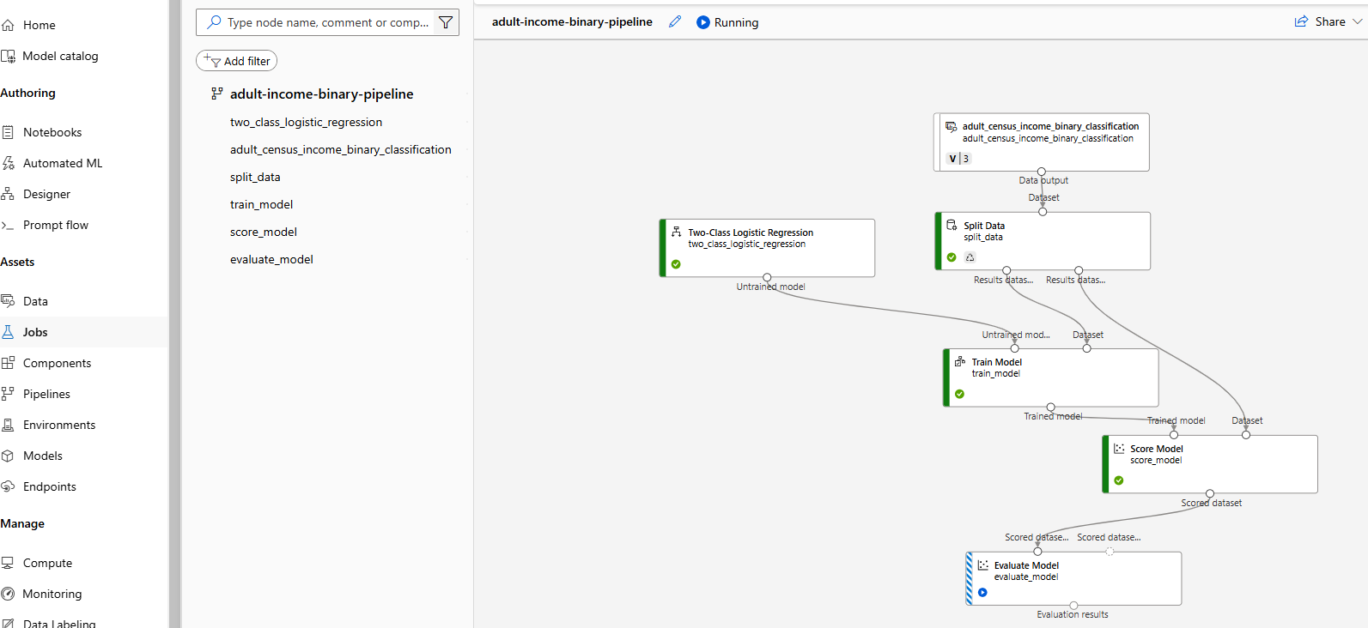

### EVALUATION OF MODEL RESULT

* **Every model has their specific evaluation metrices. Below are the details of metrices of classification model.**

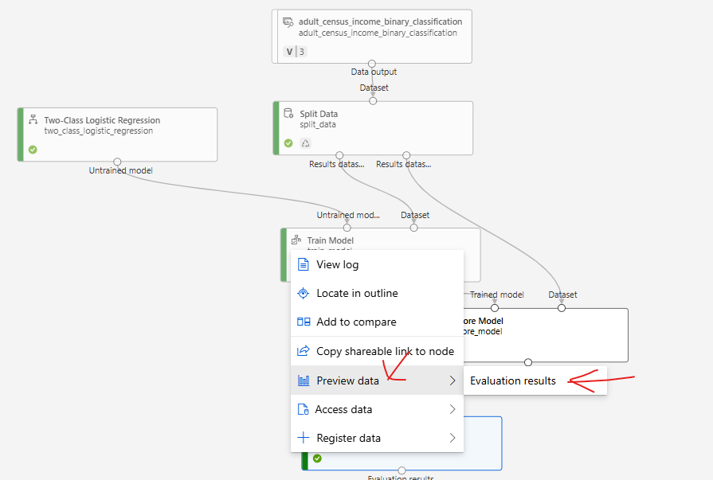

* **There are different metrics that can be used to evaluate model performance, such as Accuracy and Precision. The closer these metrics are to 1, the more accurate the model is.**
* **One of the important metrics is “Confusion Metrics”**

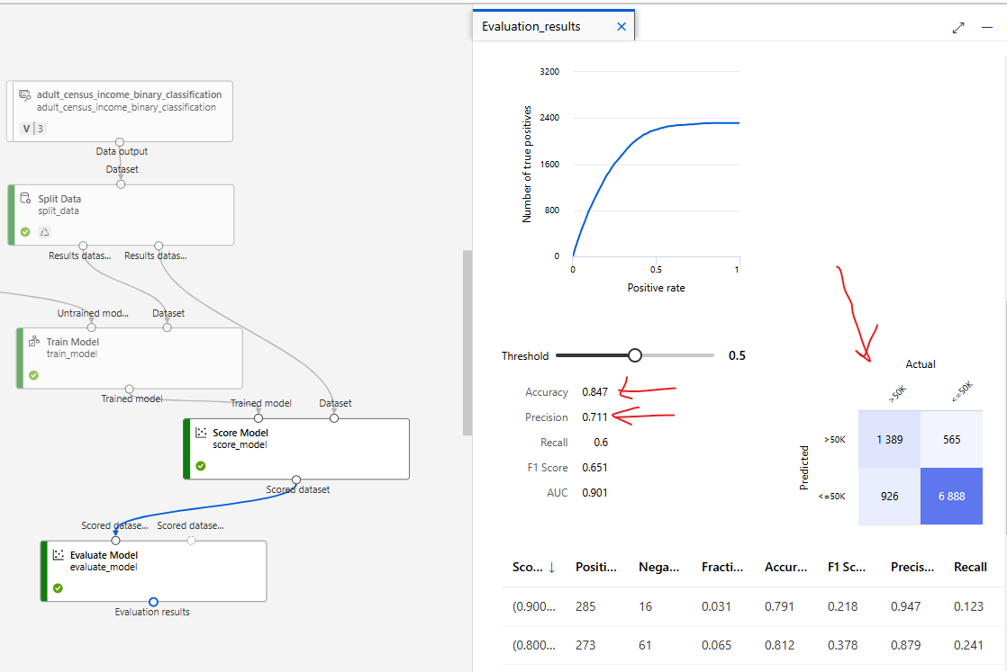

#### CONFUSION MATRICES

* Confusion matrices are the way to evaluate the performance of **a classification model**.
* It is a table that shows the number of correct and incorrect predictions made by the model.
* The table is divided into four quadrants:
  1. *true positives (correctly predicted positive instances),*
  2. *true negatives (correctly predicted negative instances),*
  3. *false positives (incorrectly predicted positive instances)*
  4. *false negatives (incorrectly predicted negative instances).*

By analyzing the values in the confusion matrix, various performance metrics such as accuracy, precision, recall, and F1 score can be calculated to assess the model's effectiveness.

|  |  |
| --- | --- |
|  |  |

## DEPLOYING THE ML MODEL

Once the evaluation is done, we can go ahead and do the deployment so that request can be submitted with an input.

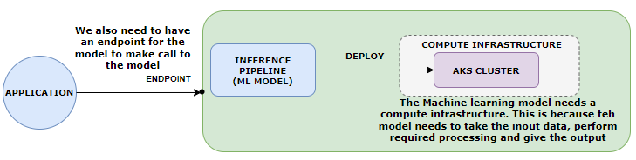

***The ML model will be deployed to AKS cluster(Compute)***

|  |  |
| --- | --- |
| Example | INPUT DATA TO MODEL AS POST REQUEST |
| * The expectation is to predict the income when the following input is provided to the model | **{"Inputs": {"WebServiceInput0": [**  **{ "age": 39,**  **"workclass": "State-gov",**  **"fnlwgt": 77516,**  **"education": "Bachelors",**  **"education-num": 13,**  **"marital-status": "Never-married",**  **"occupation": "Adm-clerical",**  **"relationship": "Not-in-family",**  **"race": "White",**  **"sex": "Male",**  **"capital-gain": 0,**  **"capital-loss": 0,**  **"hours-per-week": 60,**  **"native-country": "United-States",**  **"income": ""**  **}**  **]**  **}}** |

* After the successful run job- we need to create inference pipeline

### INFERENCE PIPELINE

* **An inference pipeline is a way to deploy and manage an end-to-end workflow for deploying machine learning models as web services**.
* It allows us to create a pipeline that consists of multiple steps, including data preprocessing, model scoring, and post-processing.
* The inference pipeline in Azure ML workspace provides a streamlined and automated process for deploying models and making predictions on new data. It helps in simplifying the deployment process, managing dependencies, and scaling the inference workload.
* With an inference pipeline, you can encapsulate the entire workflow and deploy it as a single endpoint. This makes it easy to integrate the model into applications or systems for real-time predictions.
* **The inference pipeline can be created and managed using Azure ML SDK, Azure Portal, or other Azure ML tools.**

#### CREATING AN INFERENCE PIPELINE

* Go to jobs 🡪 Open the Job

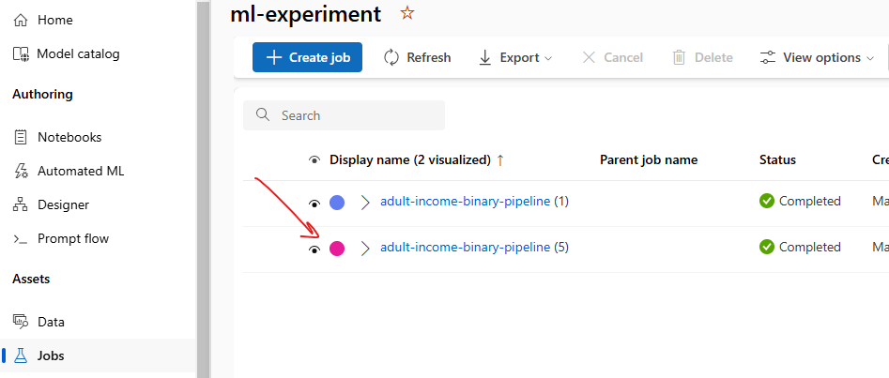

* Create a “Real time Inference Pipeline” .

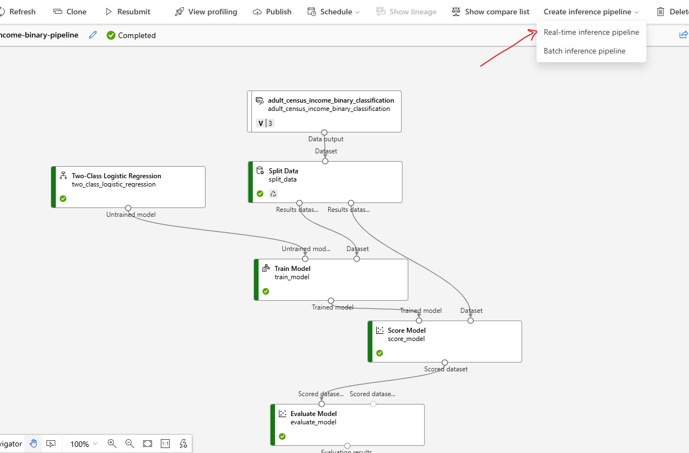

* This will create a new pipeline, with additional component “Web Service Input” and “Web Service Output”
* Note: We can remove the Evaluate Model component (as we have already evaluated the model)

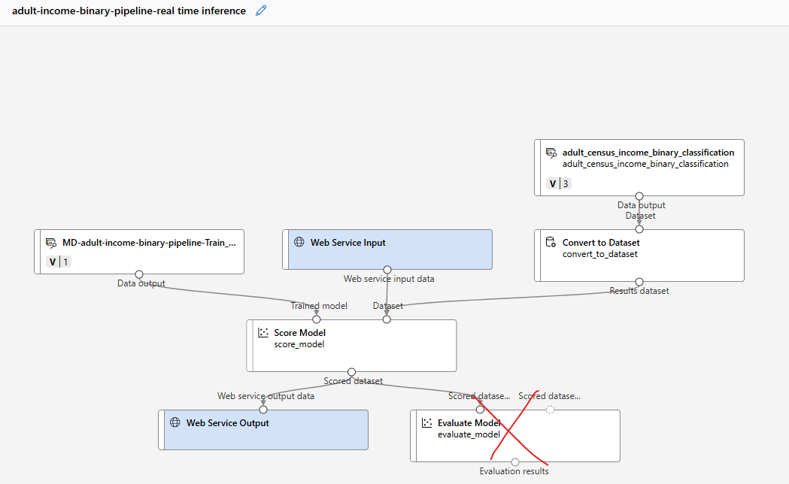

#### RUN THE INFERENCE PIPELINE

* Save and click on “Configure and Submit” to configure the Job

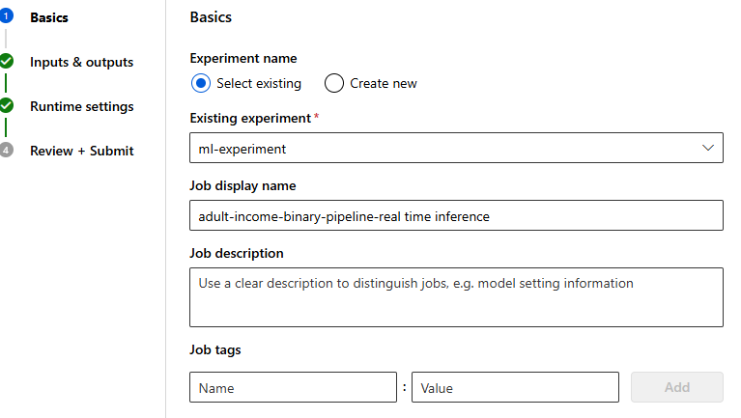

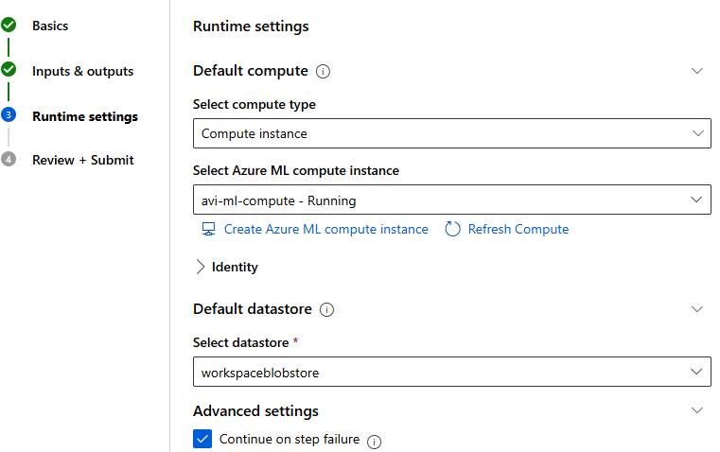

#### COMPUTE

* We will now create a compute to deploy the ML model

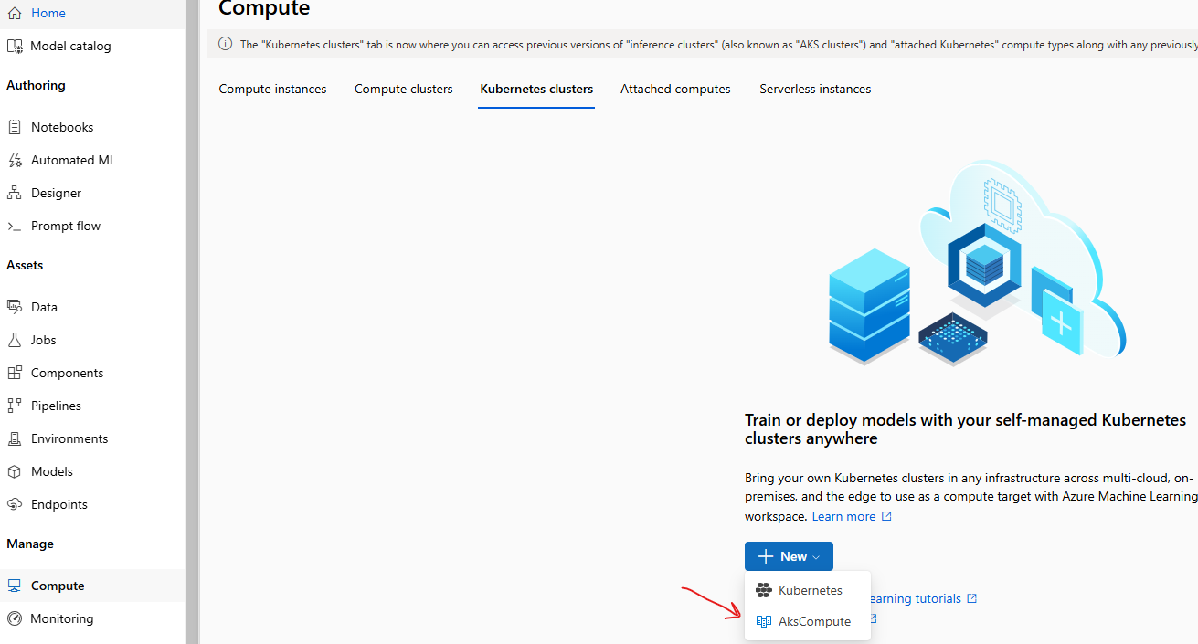

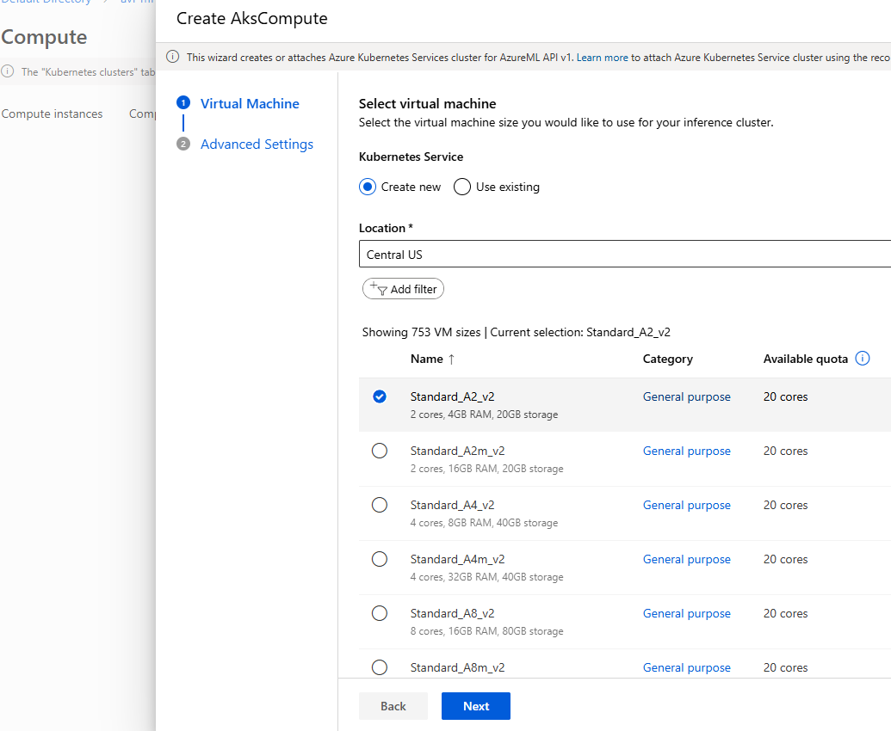

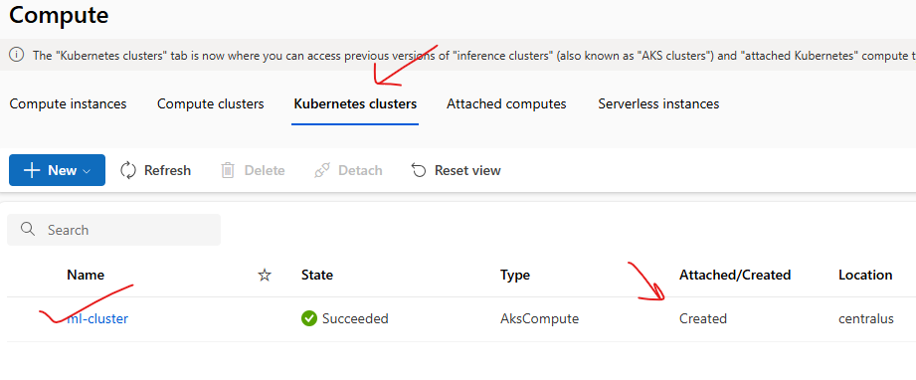

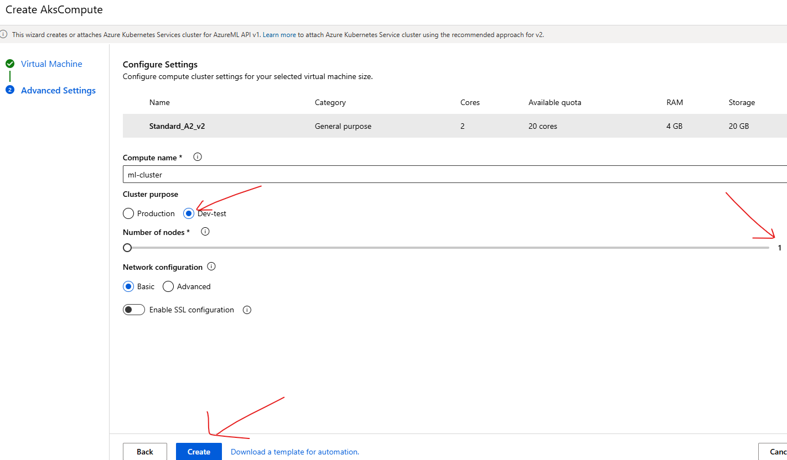

* Go to job 🡪 open the Inference pipeline Job 🡪 Deploy
* This will deploy the model to the compute instance (Kubernetes Cluster)

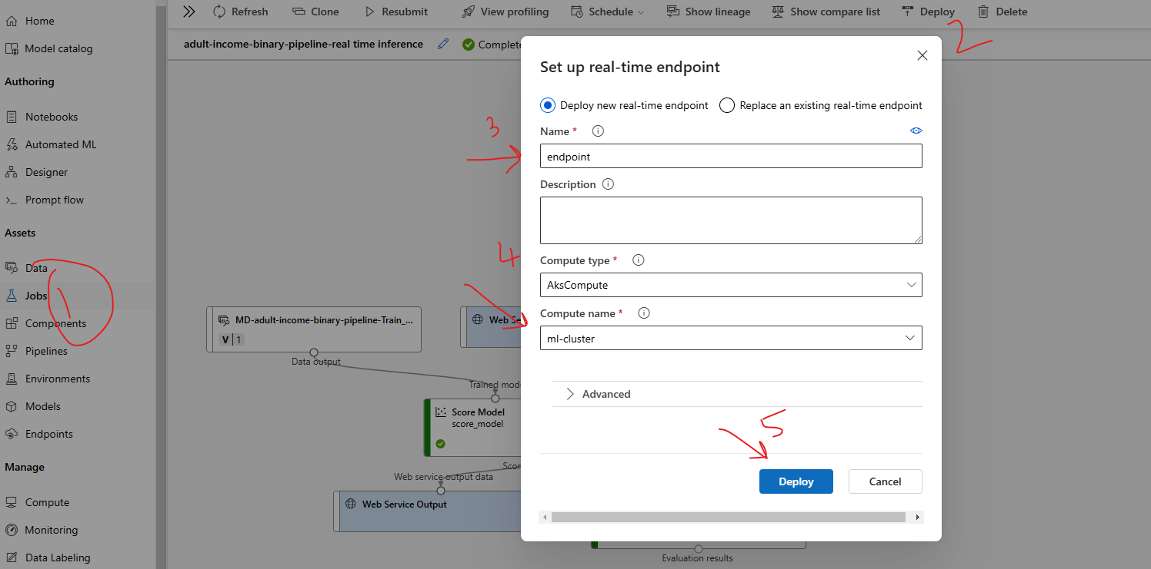

* After the deploy it will create an endpoint using which the ML model can be called. Note – The deployment status can be check using *Endpoint 🡪 Deployment State.*
* After the deployment the deployment state will be updated as “**Healthy**”

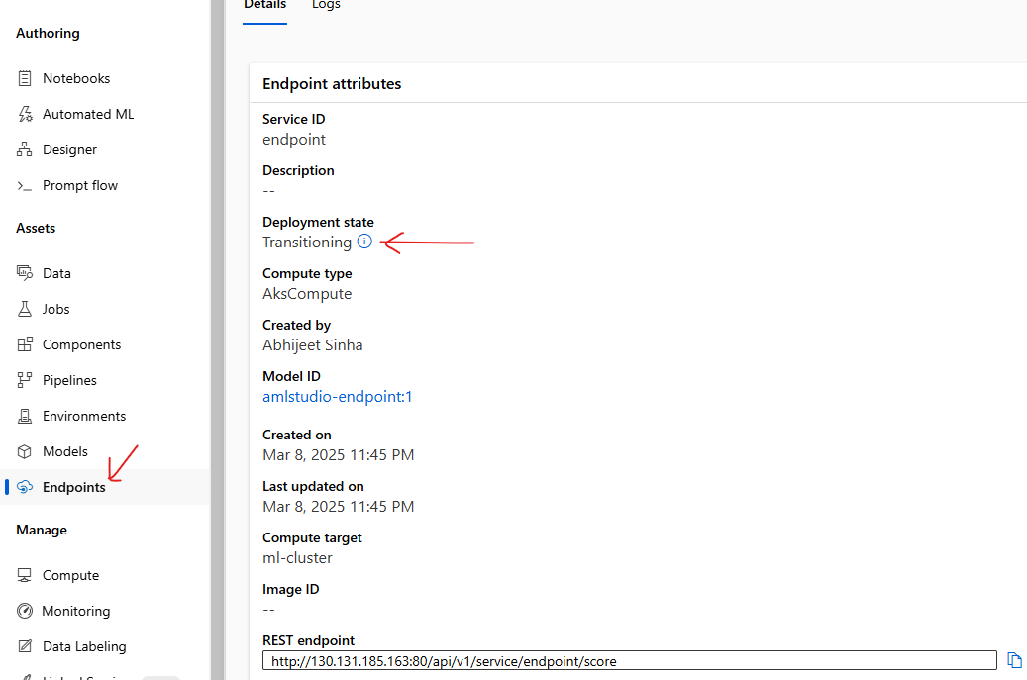

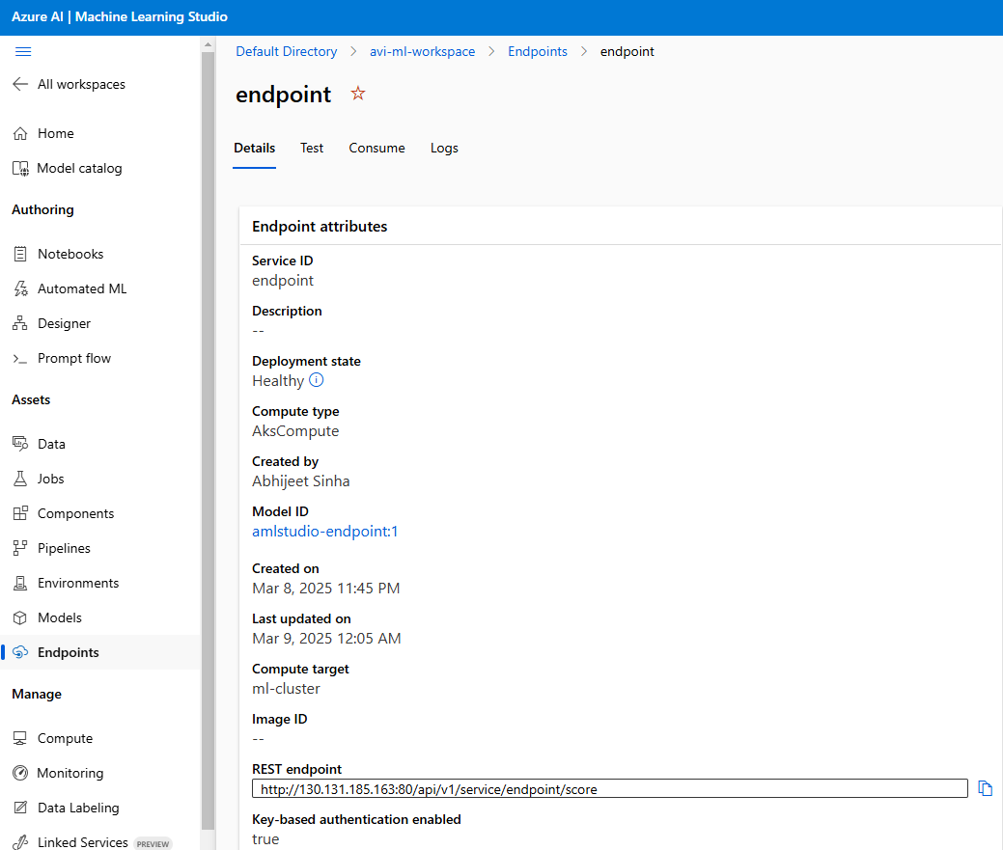

## TESTING THE MODEL

|  |  |
| --- | --- |
| INPUT DATA TO MODEL AS POST REQUEST |  |
| **{"Inputs": {"WebServiceInput0": [**  **{ "age": 39,**  **"workclass": "State-gov",**  **"fnlwgt": 77516,**  **"education": "Bachelors",**  **"education-num": 13,**  **"marital-status": "Never-married",**  **"occupation": "Adm-clerical",**  **"relationship": "Not-in-family",**  **"race": "White",**  **"sex": "Male",**  **"capital-gain": 0,**  **"capital-loss": 0,**  **"hours-per-week": 60,**  **"native-country": "United-States",**  **"income": ""**  **}**  **]**  **}}** |  |

### CONSUMING MODEL USING ENDPOINT

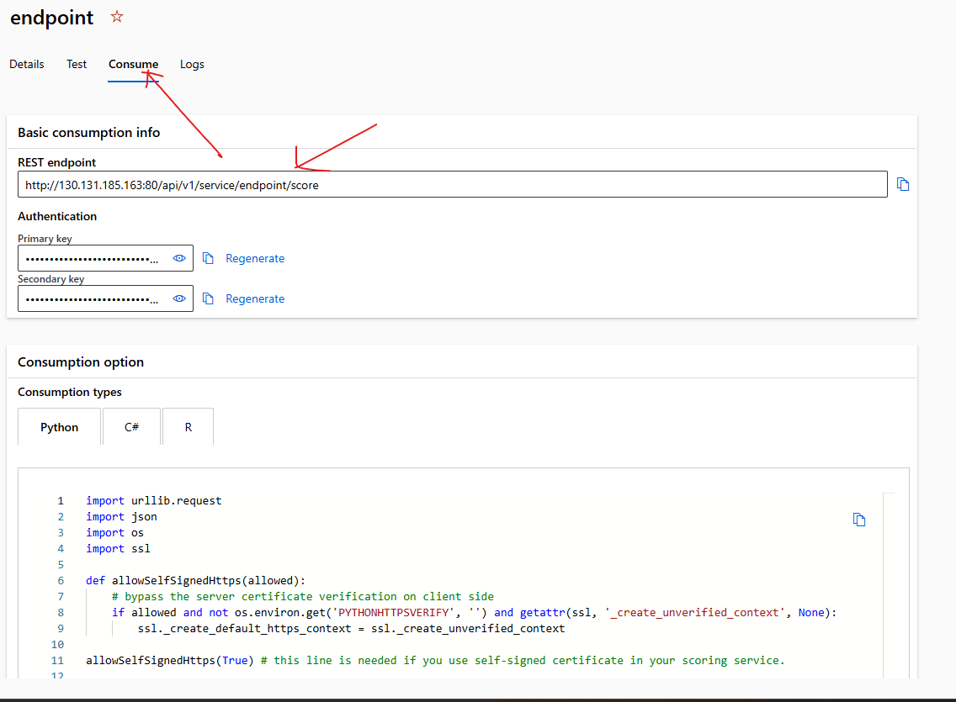

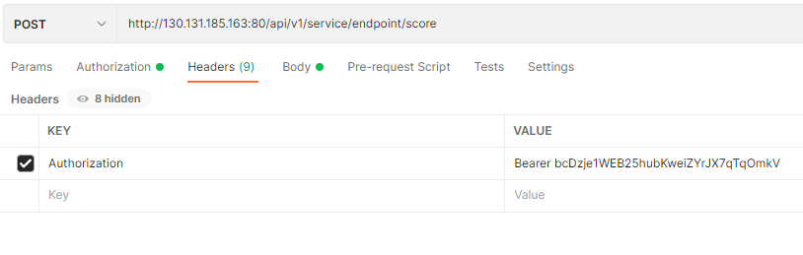

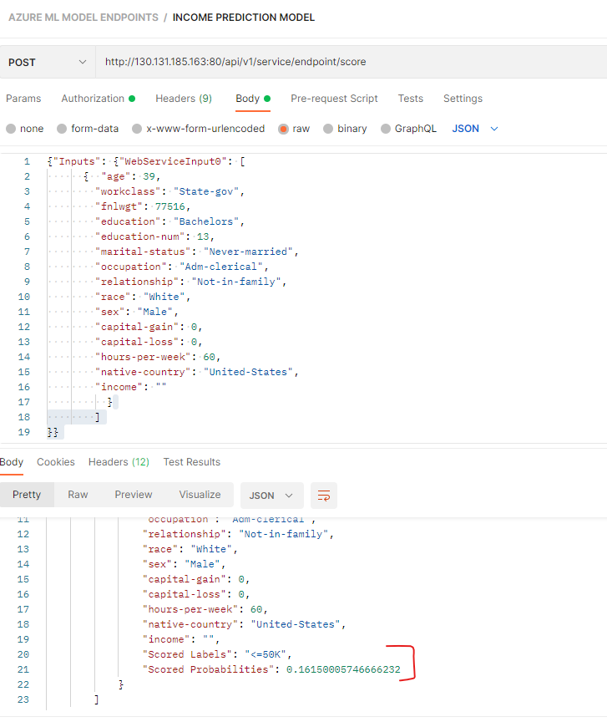

# AZURE AI VISION SERVICE

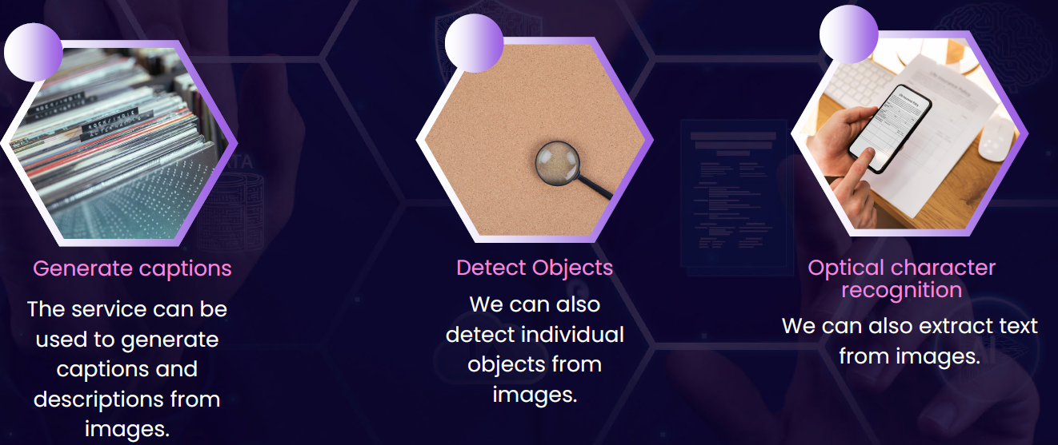

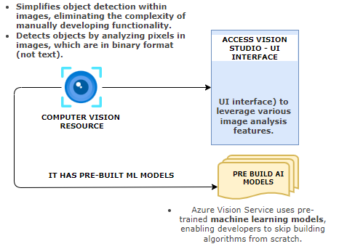

## CREATING AI VISION SERVICE

|  |  |
| --- | --- |
|  |  |

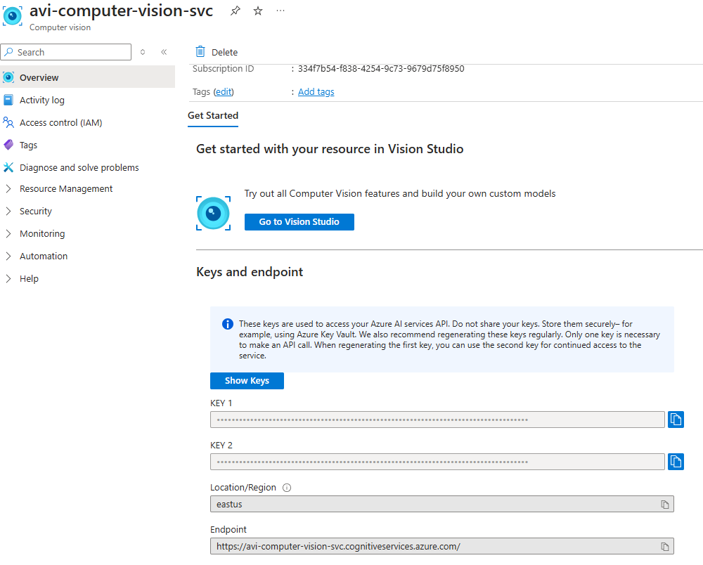

## VISION STUDIO

* To use different feature of Azure computer vision service , navigate to Visual Studio : <https://portal.vision.cognitive.azure.com/>

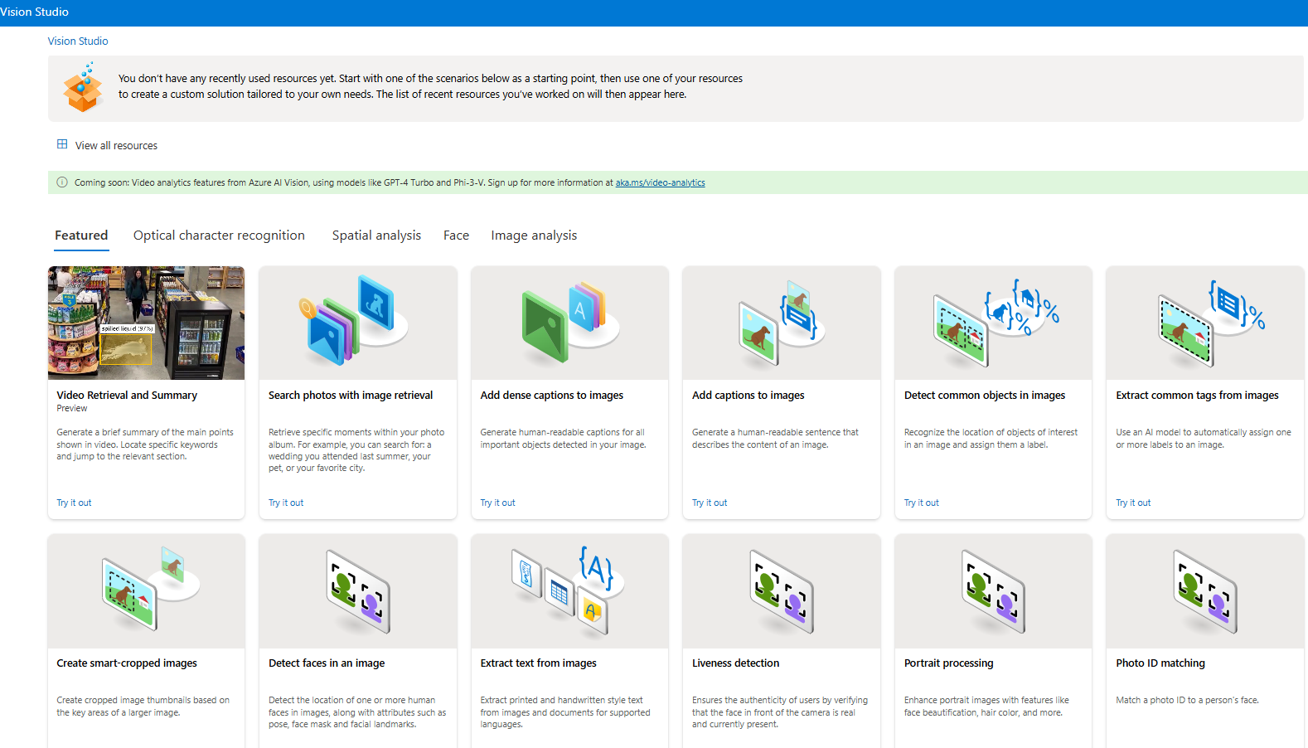

### FEATURE - EXTRACT COMMON TAGS FROM IMAGES

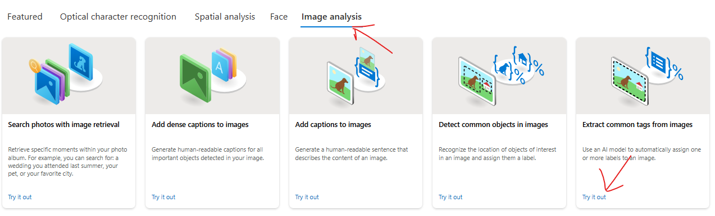

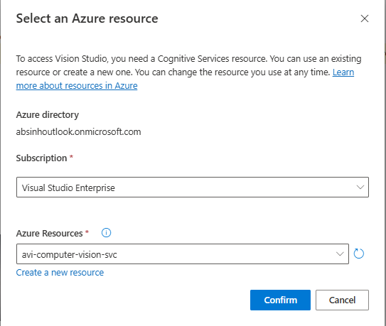

* For demo purpose select the prebuilt images. The feature will analyze the image and assign different tags to it
* Example - In below example - It understood that we do have a person within the image ,The person is having footwear in place. There is a wall behind the person.
* It's also giving a confidence score,so it has 99% confidence that this is part of a sport.It has 99% confidence that this is a person, so on and so forth. **The confidence score tells the probability of the object being correctly detected.**

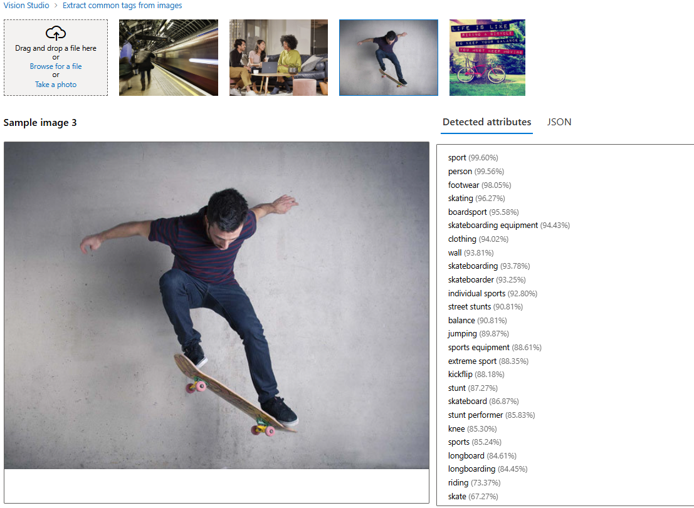

### FEATURE – ADD CAPTION TO IMAGES

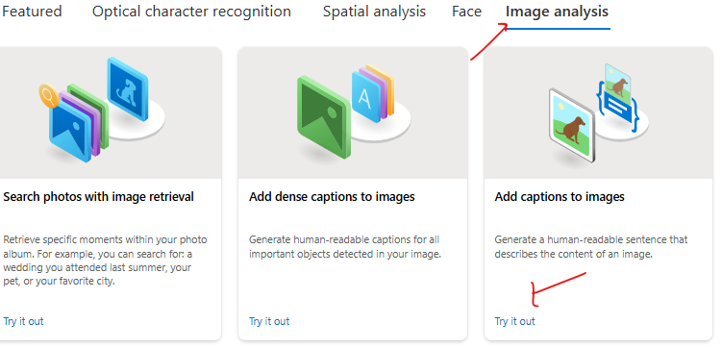

* **This feature creates a caption for the image**

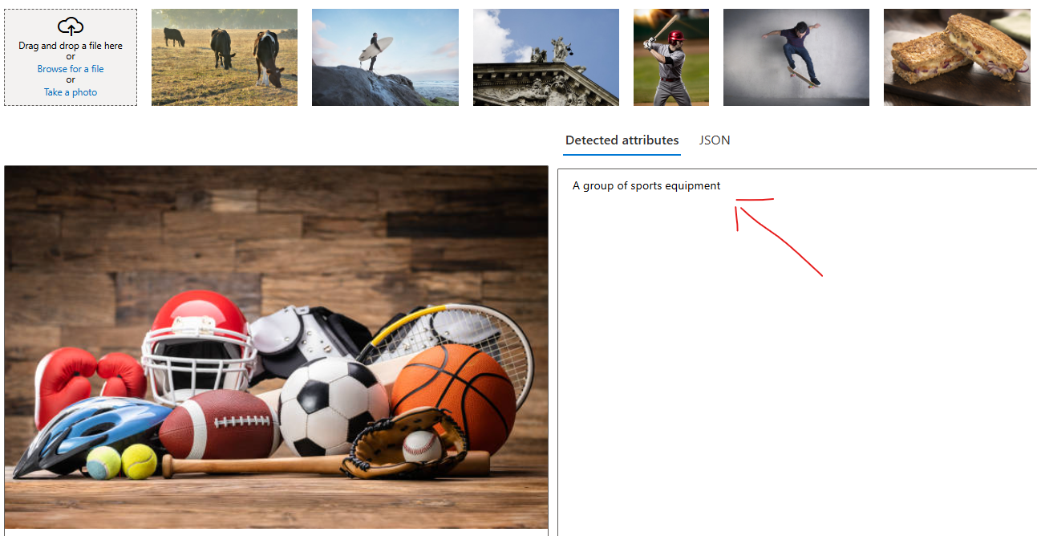

### FEATURE – OBJECT DETECTION

|  |  |
| --- | --- |
|  | * This feature identify and label common objects within an image. This is part of Azure's Object Detection functionality, integrated into the Computer Vision API, which uses pre-trained machine learning models to analyze visual content. |

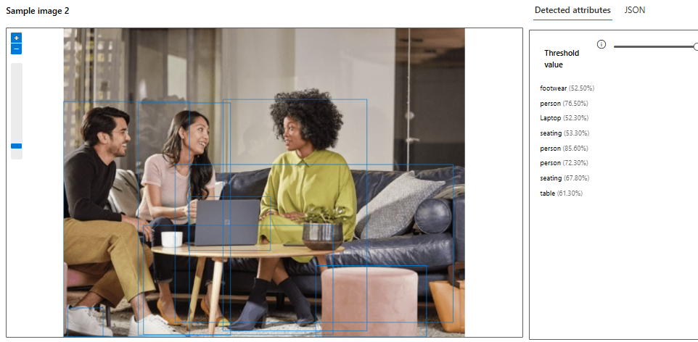

**HOW DOES OBJECT DETECTION WORK?**

* Azure Vision Studio processes the image and identifies objects by drawing bounding boxes around them.
* Each bounding box is associated with a label (object name) and a confidence score (the probability of the object being correctly detected). **Each object comes with a confidence score—e.g., 0.98—indicating the likelihood that the object is correctly identified. Higher scores mean higher accuracy**
* Detected objects can include everyday items such as cars, chairs, animals, plants, and fruits, depending on the image content.

**EXPOSING THE DATA**

* The output from these service can be exposed as an API as JSON

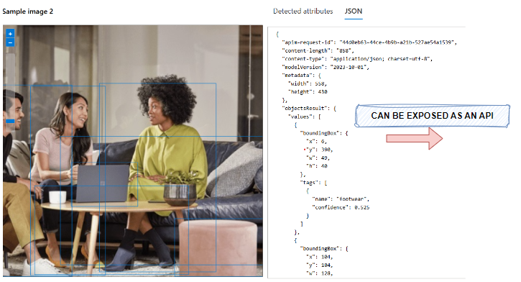

### FEATURE – OPTICAL CHARACTER RECOGNITION

|  |  |
| --- | --- |
|  | * The Optical Character Recognition (OCR) feature in Azure Vision Studio is a powerful AI-enabled tool for **extracting text from images**. * It can detect both printed and handwritten text, making it ideal for tasks like text transcription, document digitization, automated data extraction, and more.     OCR SERVICE PROVIDES:   * Text Detection: Recognizes text areas in the image. * Text Extraction: Returns the detected text along with its spatial coordinates in the image. * Language Identification: Automatically identifies the language of the extracted text. |

HOW OCR WORKS?

OCR uses machine learning models trained to analyze the pixel patterns in an image and map them to alphanumeric text. This can detect text in various formats, such as:

* Digital Document Scans (e.g., PDFs, receipts, invoices, or forms).
* Embedded Text in Images (e.g., road signs, labels, packaging).
* Handwritten Text (e.g., notes, letters, or signatures).

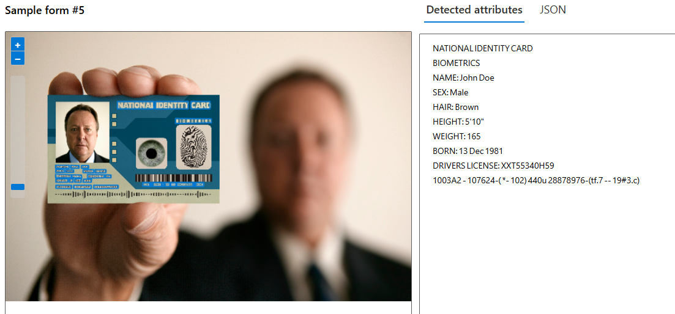

### API CALL TO VISION SERVICE – POSTMAN

* Documentation : <https://learn.microsoft.com/en-us/rest/api/computervision/image-analysis/analyze-image?view=rest-computervision-v4.0-preview%20(2023-04-01)&tabs=HTTP>

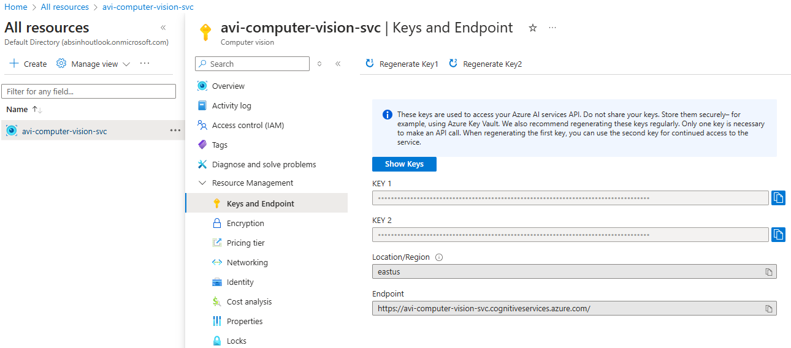

#### POSTMAN REQUEST

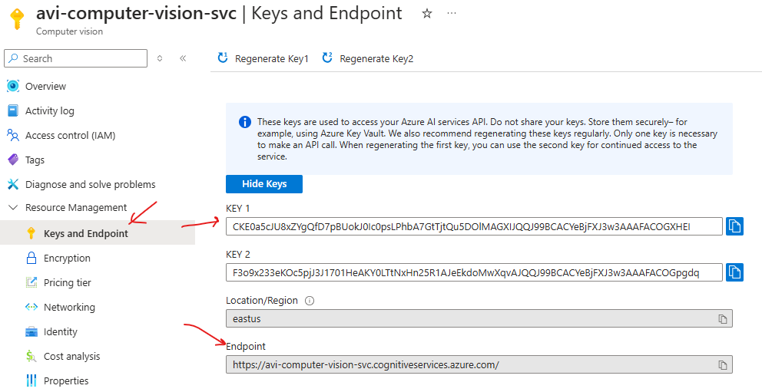

* REQUEST URL : <https://avi-computer-vision-svc.cognitiveservices.azure.com/computervision/imageanalysis:analyze?api-version=2023-04-01-preview&features=tags>
* HEADERS

|  |  |
| --- | --- |
| **Ocp-Apim-Subscription-Key** | Mention either of the key |
| **Content-Type** | application/octet-stream |

* IMAGE USED IN REQUEST



URL PARAMETERS

* We can specify the value of **features** QS based on the visual feature we are looking for

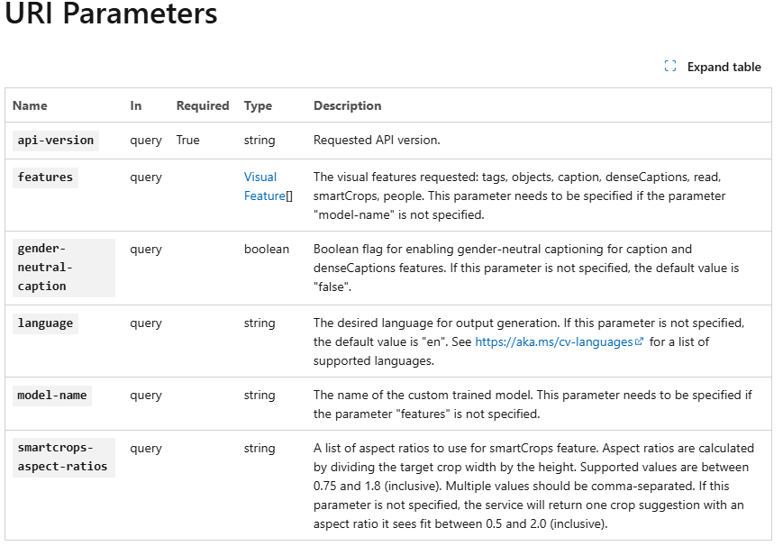

EXAMPLE

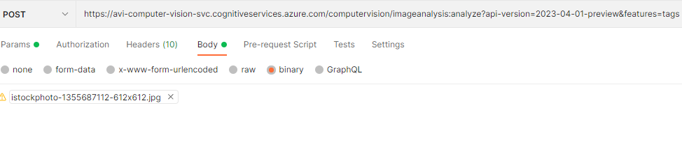

SAMPLE POSTMAN REQUEST FOR IMAGE TAGS

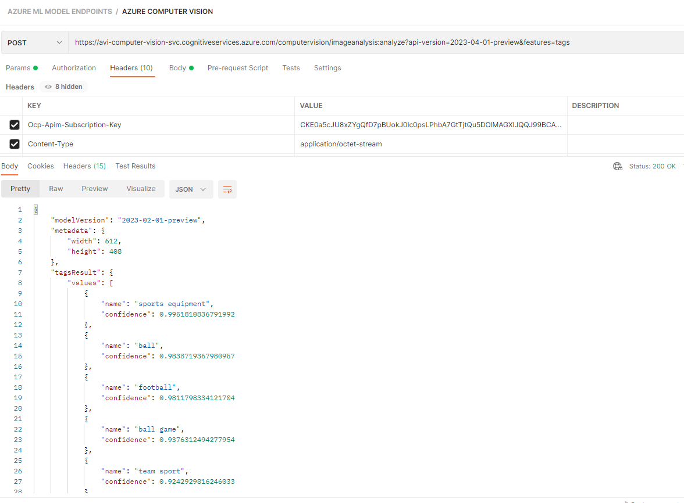

## CUSTOM VISION SERVICE

|  |
| --- |
| * This is a service that allows us to build and deploy our own image identification models. * We can use our own labels to train the model. * We can use Custom Vision via the Custom Vision portal. Or we can use it from a programming language by using the available SDK or REST API. * The Custom Vision service will allow us to first train a model with our own set of images. We can label the images to train the model. |

### SETTING UP CUSTOM VISION SERVICE

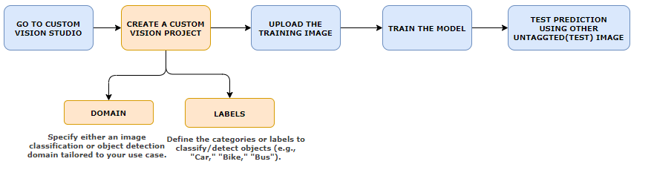

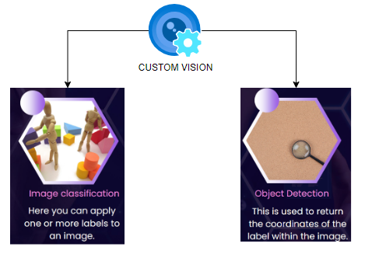

### CREATING A CUSTOM VISION SERVICE

* In the custom vision service - we first train a model based on images and then we can use it to predict right values based on images itself

|  |  |
| --- | --- |
|  |  |

* The custom vision deployment creates 2 resources

|  |  |
| --- | --- |
| [avicustomvisionsvc](https://portal.azure.com/#@absinhoutlook.onmicrosoft.com/resource/subscriptions/334f7b54-f838-4254-9c73-9679d75f8950/resourceGroups/ml-rg/providers/Microsoft.CognitiveServices/accounts/avicustomvisionsvc) | For Training |
| [avicustomvisionsvc-Prediction](https://portal.azure.com/#@absinhoutlook.onmicrosoft.com/resource/subscriptions/334f7b54-f838-4254-9c73-9679d75f8950/resourceGroups/ml-rg/providers/Microsoft.CognitiveServices/accounts/avicustomvisionsvc-Prediction) | For Prediction |

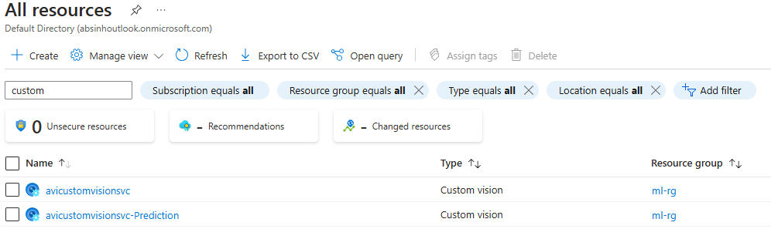

### CUSTOM VISION PORTAL

* Navigate to Custom Vision Portal : <https://www.customvision.ai/>
* Create a new Project. The project can 2 types
  + Classification: Classify image based on training data
  + Object Detection: To detect object within the image

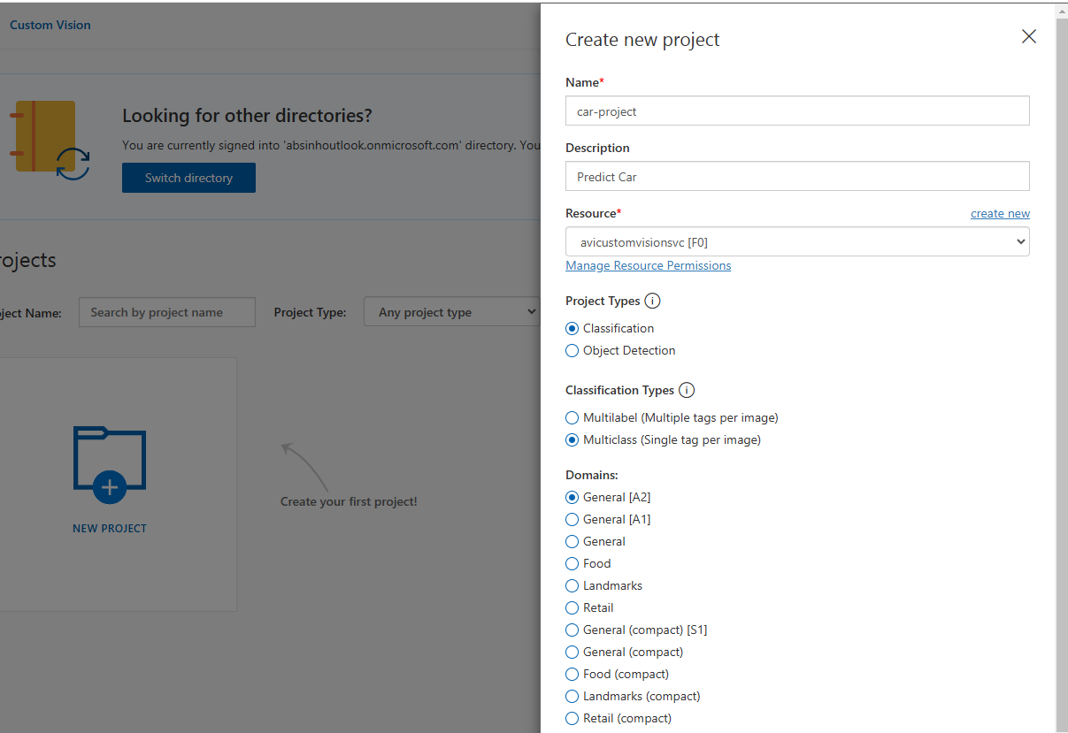

* In the below example - lets create “Classification” Project type and Classification Types 🡪 Multiclass 🡺 Then Create Project
* Add Image to train the Model (We will take example of different cars)

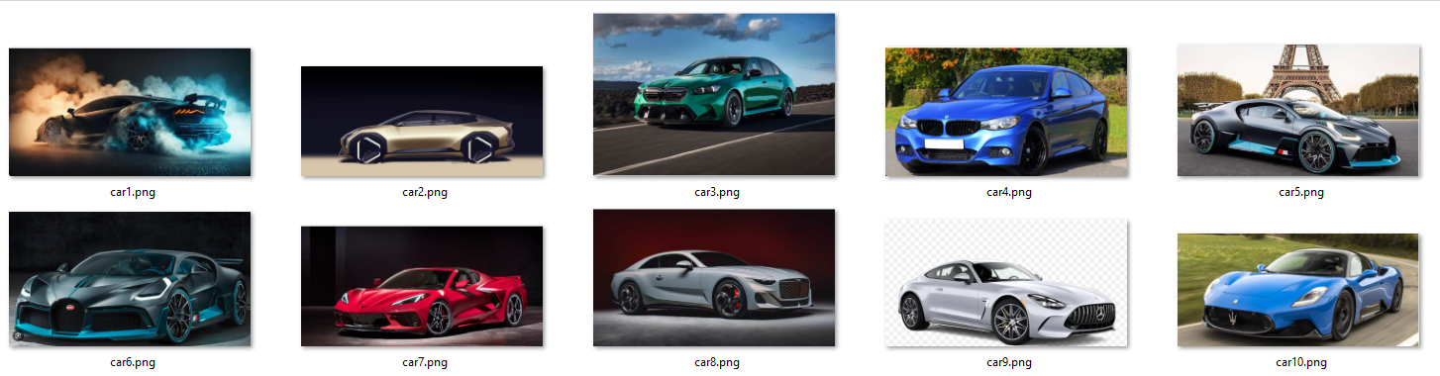

#### ADD/ UPLOAD IMAGES

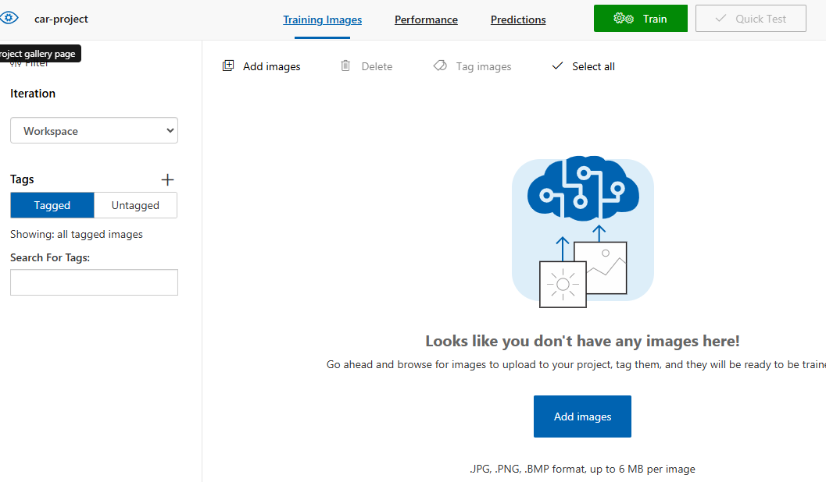

#### ADD TAG TO IMAGE

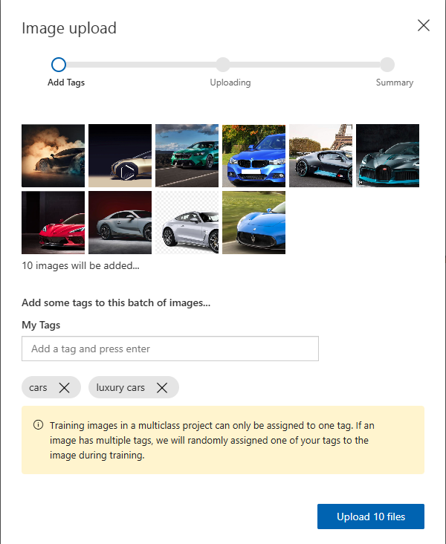

#### TRAIN THE MODEL BASED ON UPLOADED IMAGES

* Train the model based on uploaded image

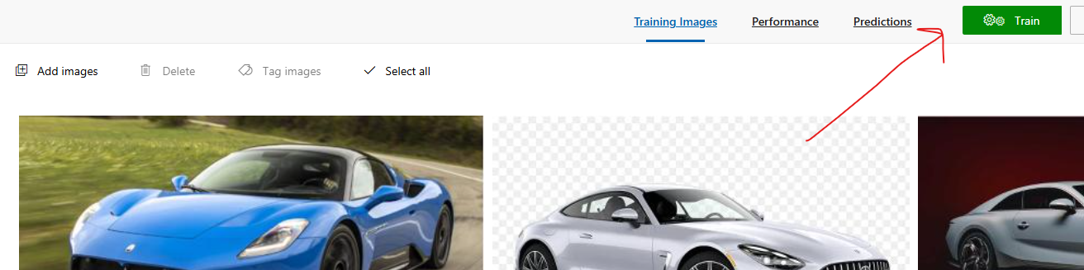

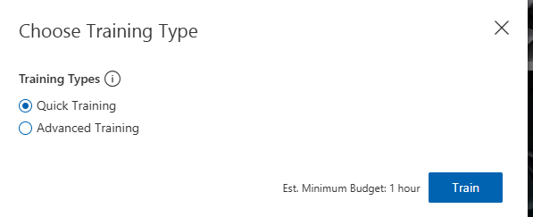

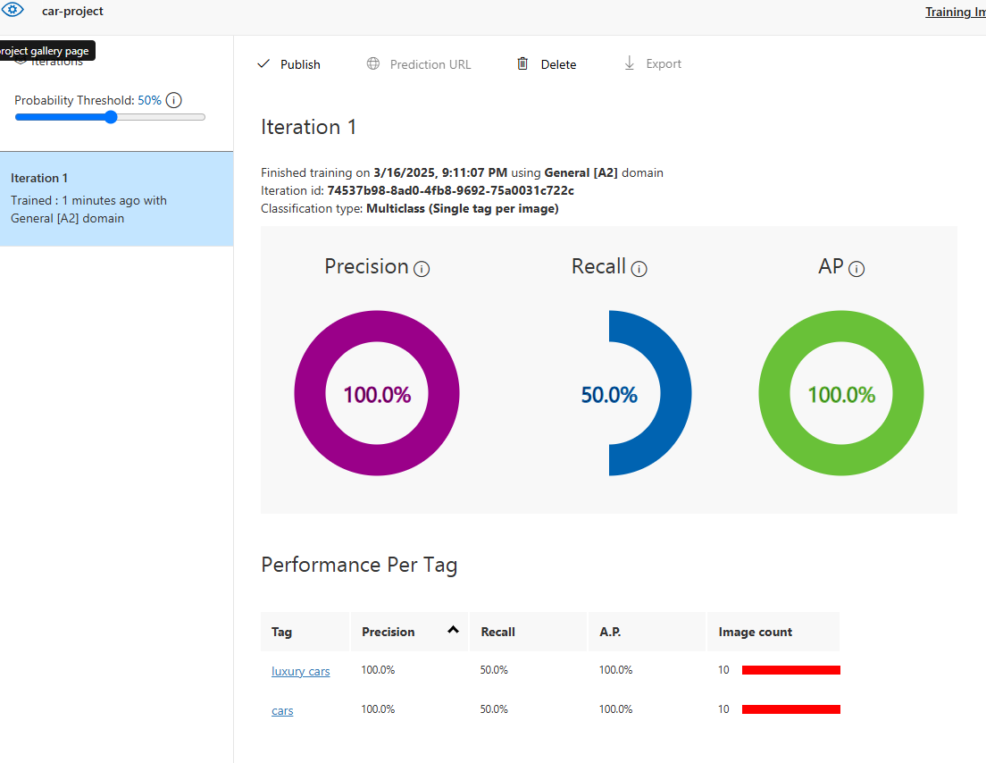

#### PUBLISH THE MODEL

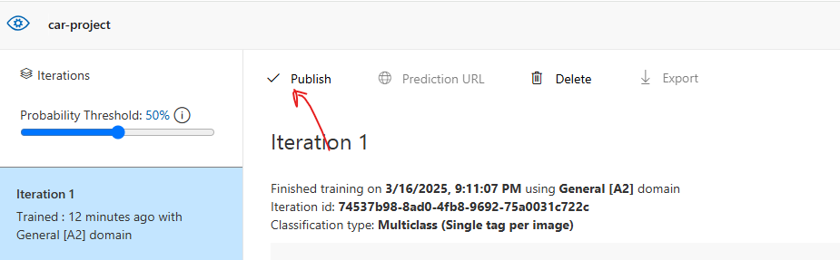

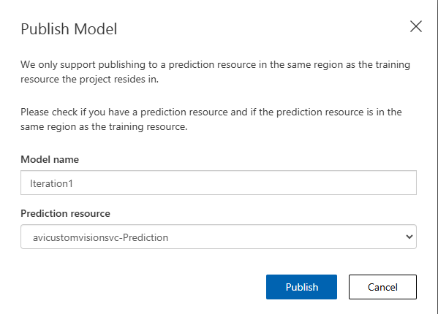

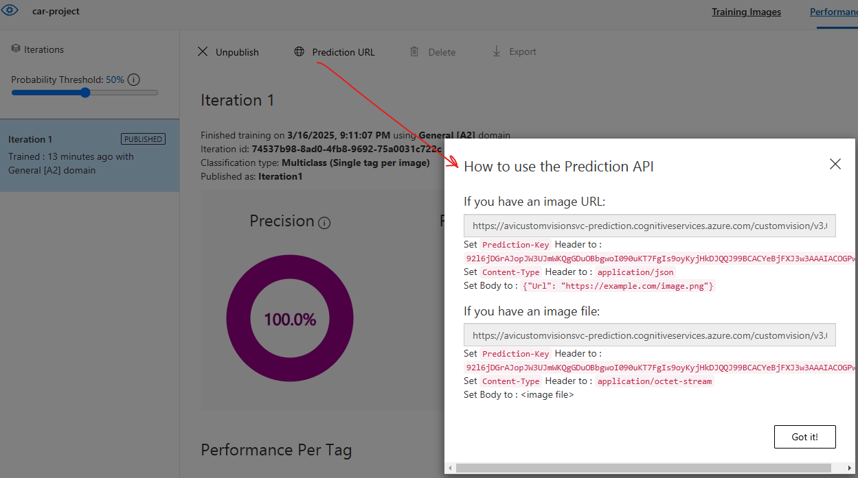

#### RUN THE TEST

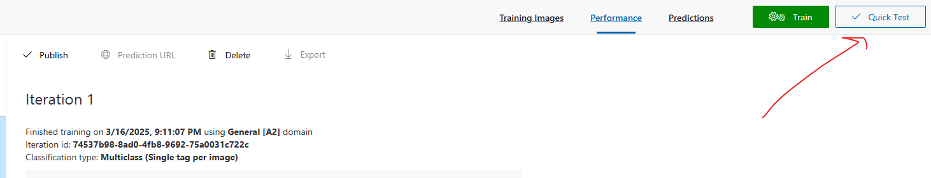

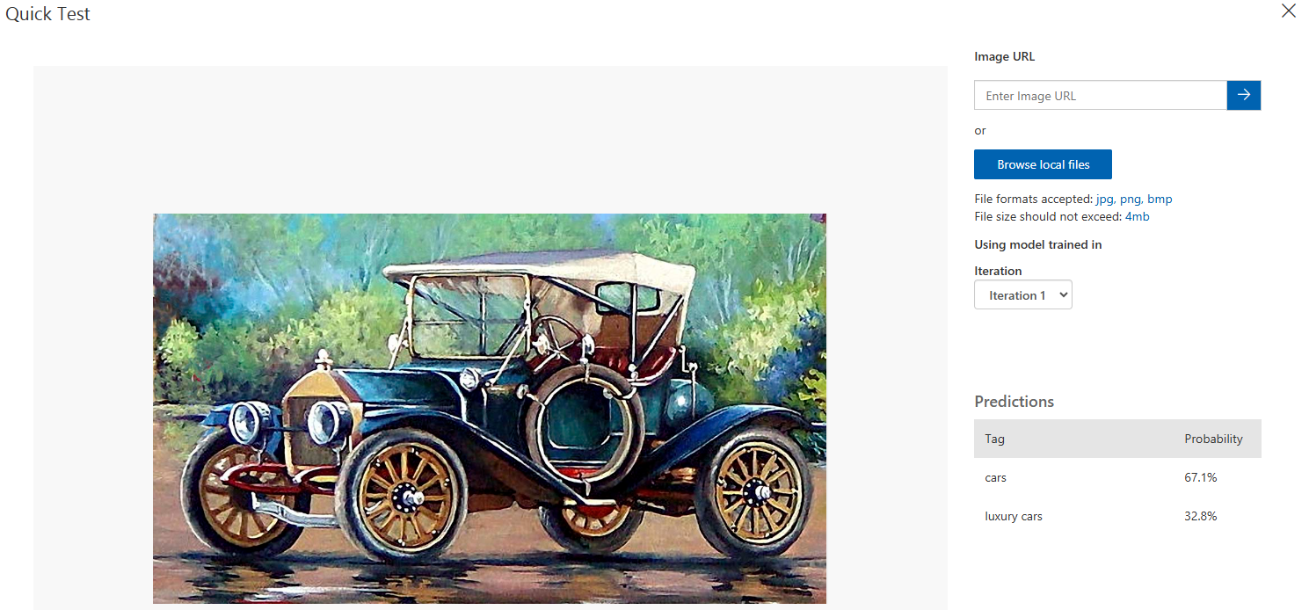

## FACE SERVICE

* This is a service that allows us to work with human faces within images.
* There are also some certain attributes that we can get about the face - Accessories - whether the human is wearing glasses, mask.
* **Face Recognition**
  + We can create a PersonGroup object that holds human faces.
  + We can then identify a particular face from the PersonGroup object.
* We can also use the Verify API to verify if a face and a Person object is the same.

### CREATING FACE API SERVICE

|  |  |
| --- | --- |
|  |  |

#### FEATURES IN FACE SERVICE

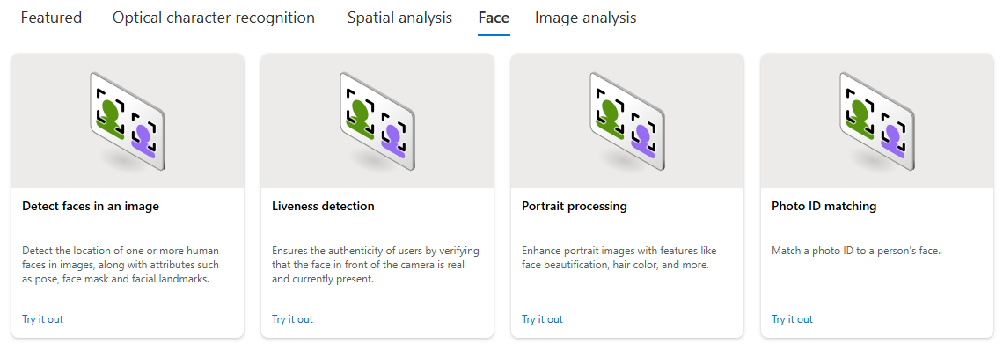

#### FEATURE - DETECT FACES IN IMAGE

|  |  |
| --- | --- |
|  | * This feature can detect faces from the image |

* Select the Resource and Subscription 🡪 Confirm
* Select / Browse the image to analyze

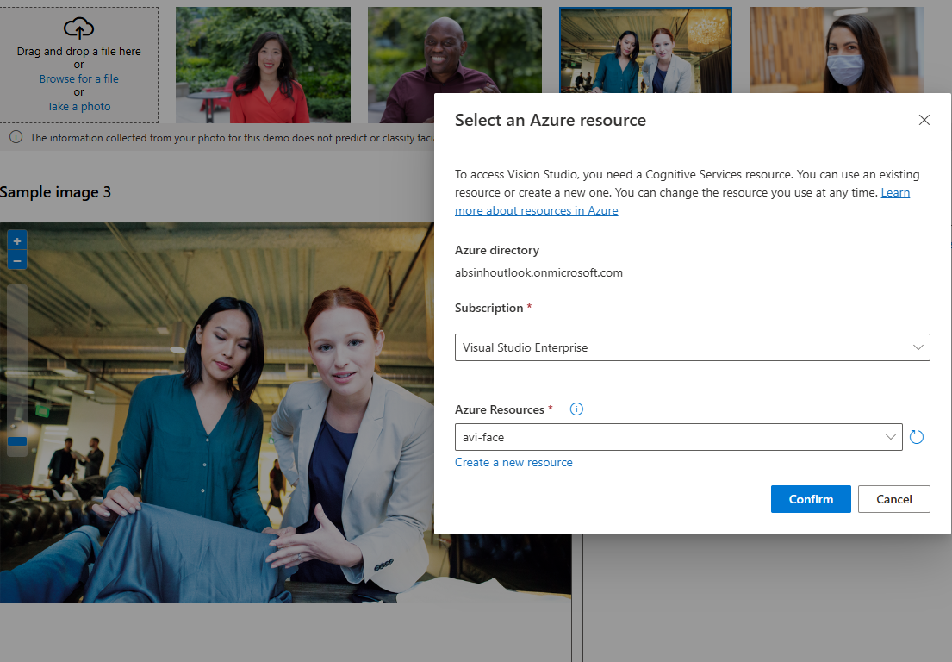

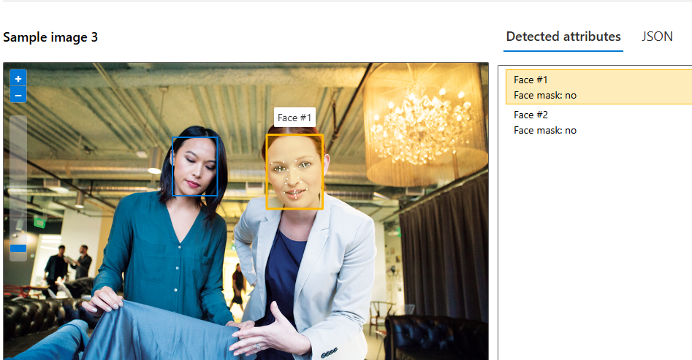

* The JSON data shows the attributes of the face in the image

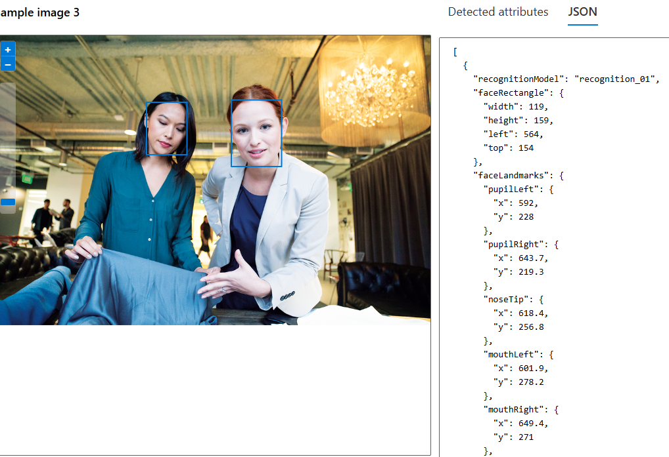

### CALLING FACE API SERVICE USING POSTMAN

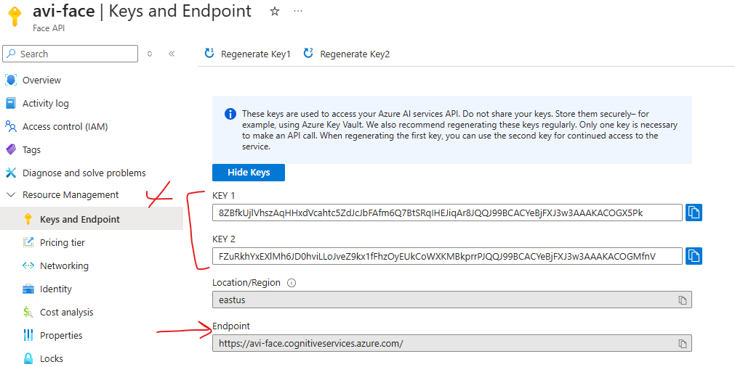

* Documentation : <https://learn.microsoft.com/en-us/rest/api/face/face-detection-operations/detect?view=rest-face-v1.2-preview.1&tabs=HTTP>

#### REQUEST

* REQUEST URL: <https://avi-face.cognitiveservices.azure.com/face/v1.2-preview.1/detect?_overload=detect&detectionModel=detection_01&recognitionModel=recognition_03&returnFaceAttributes=glasses,headPose,occlusion,accessories,blur,exposure,noise,qualityForRecognition&returnFaceLandmarks=True>
* **HEADERS**

|  |  |
| --- | --- |
| **Ocp-Apim-Subscription-Key** | Mention either of the key |
| **Content-Type** | application/octet-stream |

* **BODY**

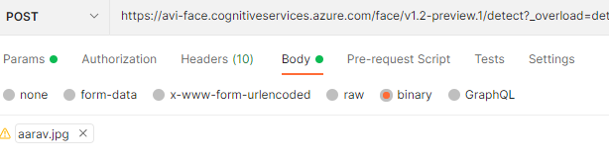

**EXAMPLE: POSTMAN**

QUERY STRINGS

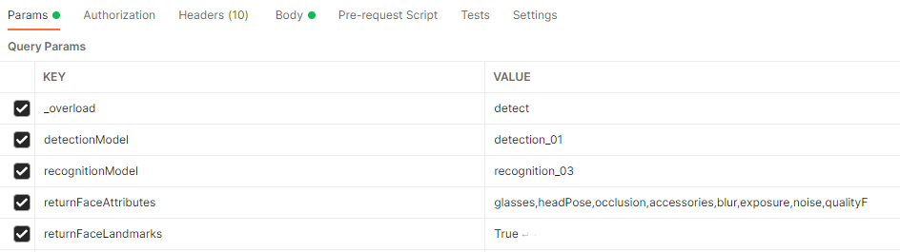

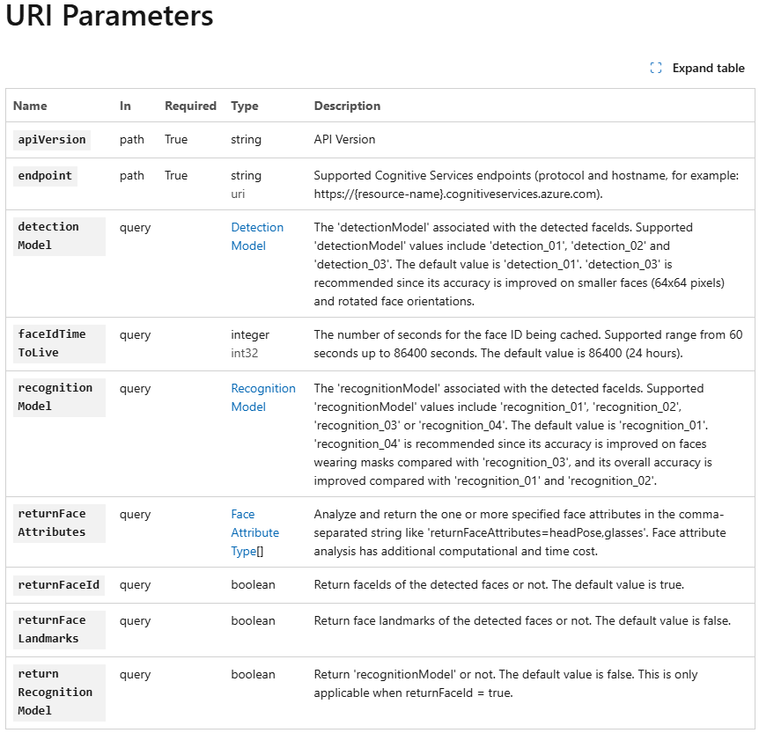

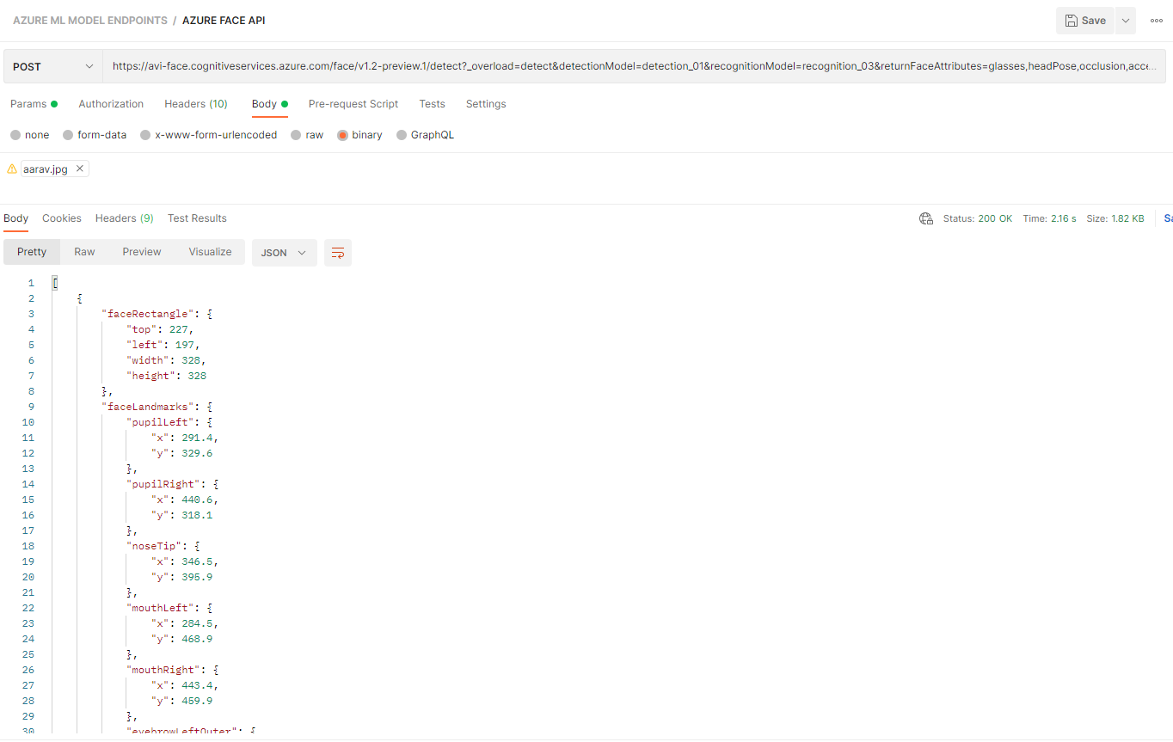

## OTHER FACE API FEATURES

* Documentation : <https://learn.microsoft.com/en-us/azure/ai-services/computer-vision/overview-identity>

# AZURE AI DOCUMENT INTELLIGENCE SERVICE

* Azure AI Document Intelligence is a cloud-based Azure service designed to process and extract data from documents.
* This service includes prebuilt machine learning models to extract specific information from common document types, such as:
  + Invoices: Extract details like customer name and invoice amount.
  + Bank Statements.
  + Contracts.
  + Credit Card Statements.
  + Tax Forms.
* It enables applications to automate the extraction of key details from documents, enhancing efficiency (e.g., linking invoice information to customer profiles).
* In addition to prebuilt models, users can create their own custom models tailored to specific document types and business needs

## CREATING A DOCUMENT INTERLLIGENCE SERVICE

|  |  |
| --- | --- |
|  |  |

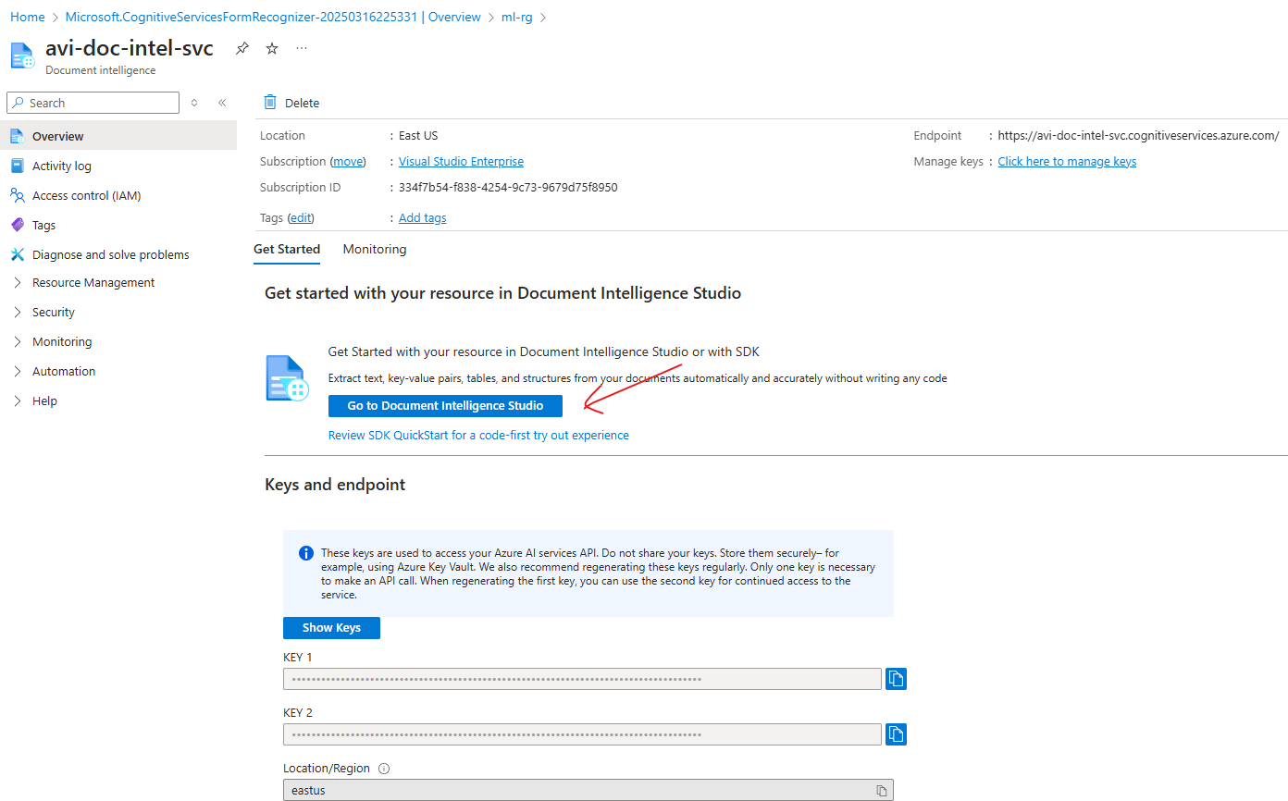

## DOCUMENT INTELLIGENCE STUDIO

* URL: <https://documentintelligence.ai.azure.com/studio/>

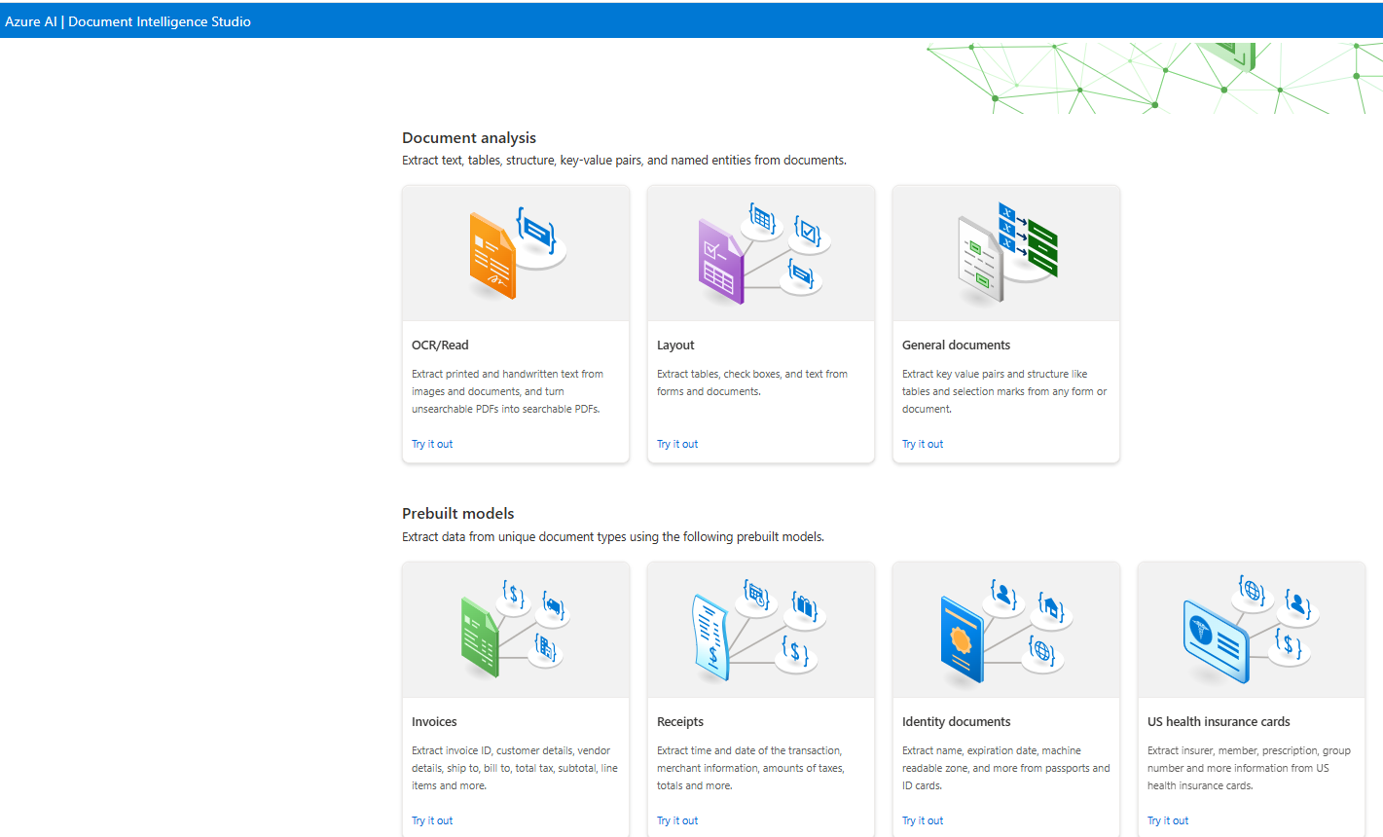

Let’s use the Invoices Prebuilt model and use the existing invoice

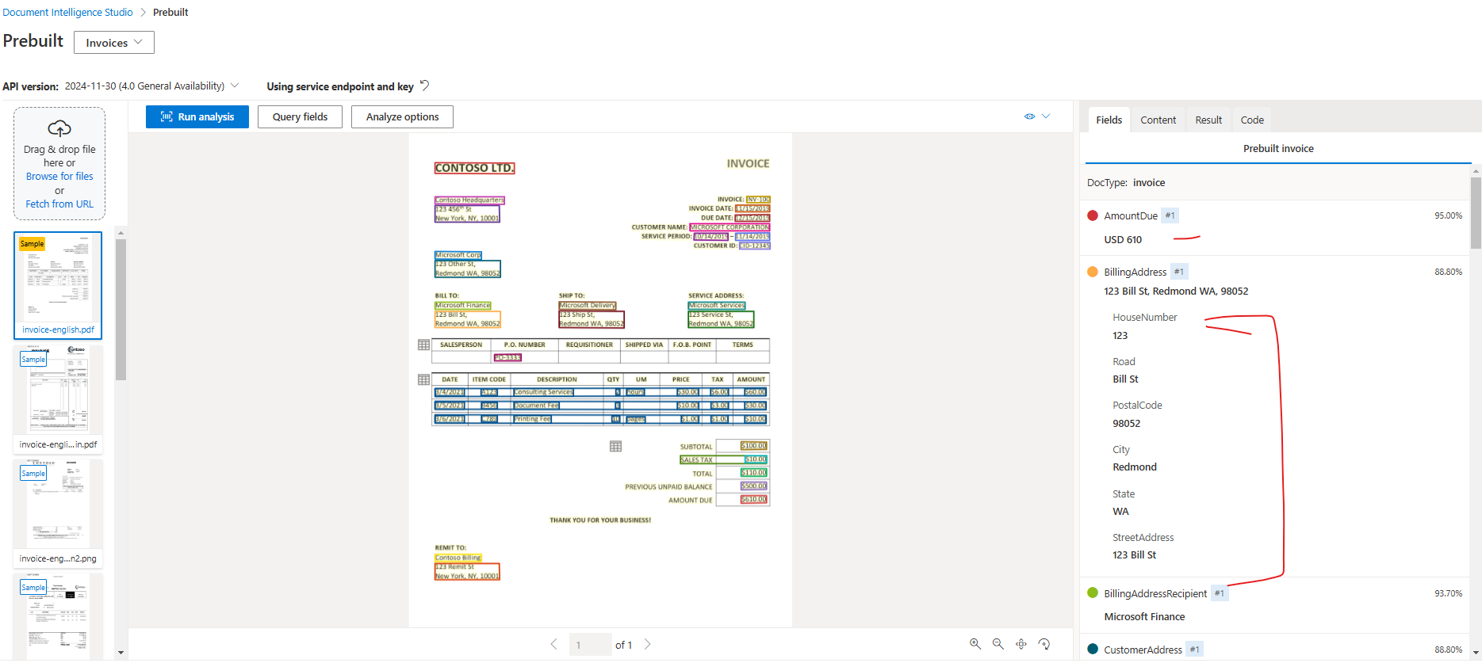

CUSTOM INVOICE

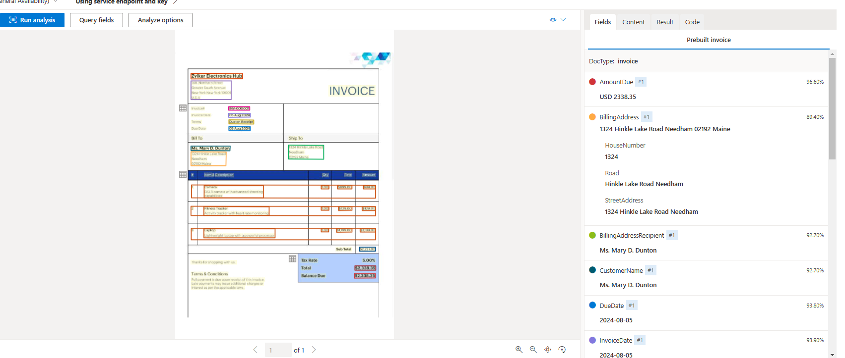

# AZURE AI FOUNDRY

# NATURAL LANGUAGE PROCESSING

## SERVICES FOR NLP IN AZURE

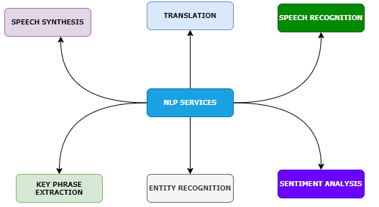

|  |  |  |
| --- | --- | --- |
|  | **DEFINATION & PURPOSE** | **AZURE SERVICE & USE CASE** |
| **KEY PHRASE EXTRACTION** | * **Definition**: Extract significant and relevant phrases or terms from a piece of text. * **Purpose**: Summarize text by identifying the most important information. | * **AZURE SERVICE**: Azure *Azure Text Analytics*: Automatically extracts key phrases to summarize documents, emails, or articles. * Use Case:   + Extracting main points from customer feedback or reports.   + Summarizing documentation. |
| **ENTITY RECOGNITION** | * **Definition**: Identify specific entities in text, such as names, dates, locations, organizations, etc. * **Purpose**: Extract structured information from unstructured text. | * **AZURE SERVICE:** *Azure Text Analytics*: Offers Named Entity Recognition (NER), which identifies entities in text documents. * **USE CASE**:   + Detecting people or organizations in email data.   + Extracting scheduled dates from documents. |
| **SENTIMENT ANALYSIS** | * **Definition**: Determine the emotional tone of text (positive, neutral, or negative). * **Purpose**: Analyze how users feel about a product, service, or topic. | * **AZURE SERVICE**: *Azure Text Analytics*: Provides sentiment scores for text inputs. * **USE CASE**:   + Monitoring brand sentiment from social media or customer reviews.   + Identifying trends in feedback surveys. |
| **TRANSLATION** | * **Definition**: Translate text from one language to another. * **Purpose**: Break language barriers and enable communication between different language speakers. | * **AZURE SERVICE**: *Azure Translator*: Supports translation into 90+ languages and provides customizable models for domain-specific translations. * **USE CASE**:   + Multilingual customer service chatbots.   + Translating marketing material for global audiences. |
| **SPEECH RECOGNITION** | * **Definition**: Converts spoken language (audio) into transcribed text. * **Purpose**: Enable speech processing for applications like transcription services. | * **AZURE SERVICE**:*Azure Speech-to-Text*: Automatically transcribes speech into text in various languages and accents. * **USE CASE**:   + Real-time transcription of meetings or interviews.   + Automated voice capture for note-taking. |
| **SPEECH SYNTHESIS** | * **Definition**: Converts text-based content into synthetic human-like speech. * **Purpose**: Enable communication from machines using natural-sounding speech. | * **AZURE SERVICE**:*Azure Text-to-Speech*: Offers natural-sounding speech synthesis and custom voice models. * **USE CASE**:   + Text-to-speech conversions for virtual assistants and chatbots.   + Interactive announcements, such as in public service |

## AZURE LANGUAGE SERVICE

### CREATING LANGUAGE SERVICE

|  |  |
| --- | --- |
|  | * Default features available with the language service |

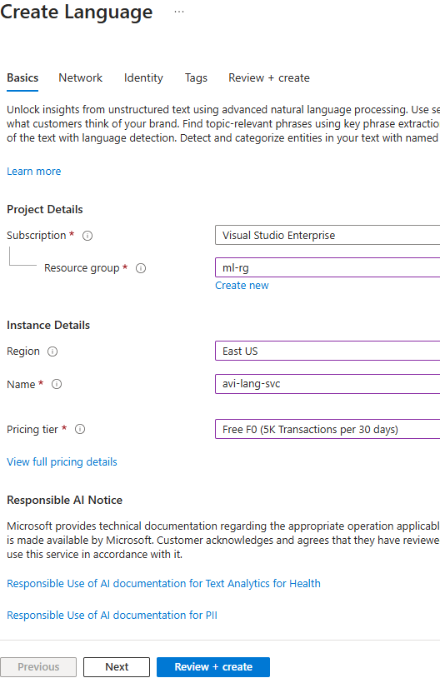

#### LAUNCH LANGUAGE SERVICE

* URL : <https://language.cognitive.azure.com/home>

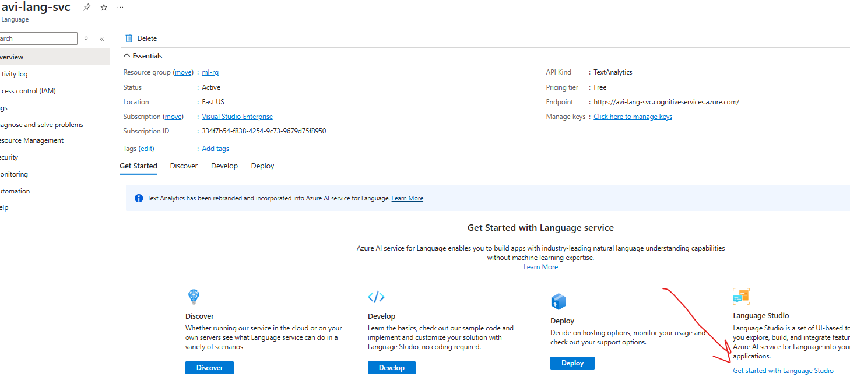

## KEY FEATURES

### KEY PHRASE EXTRACTION

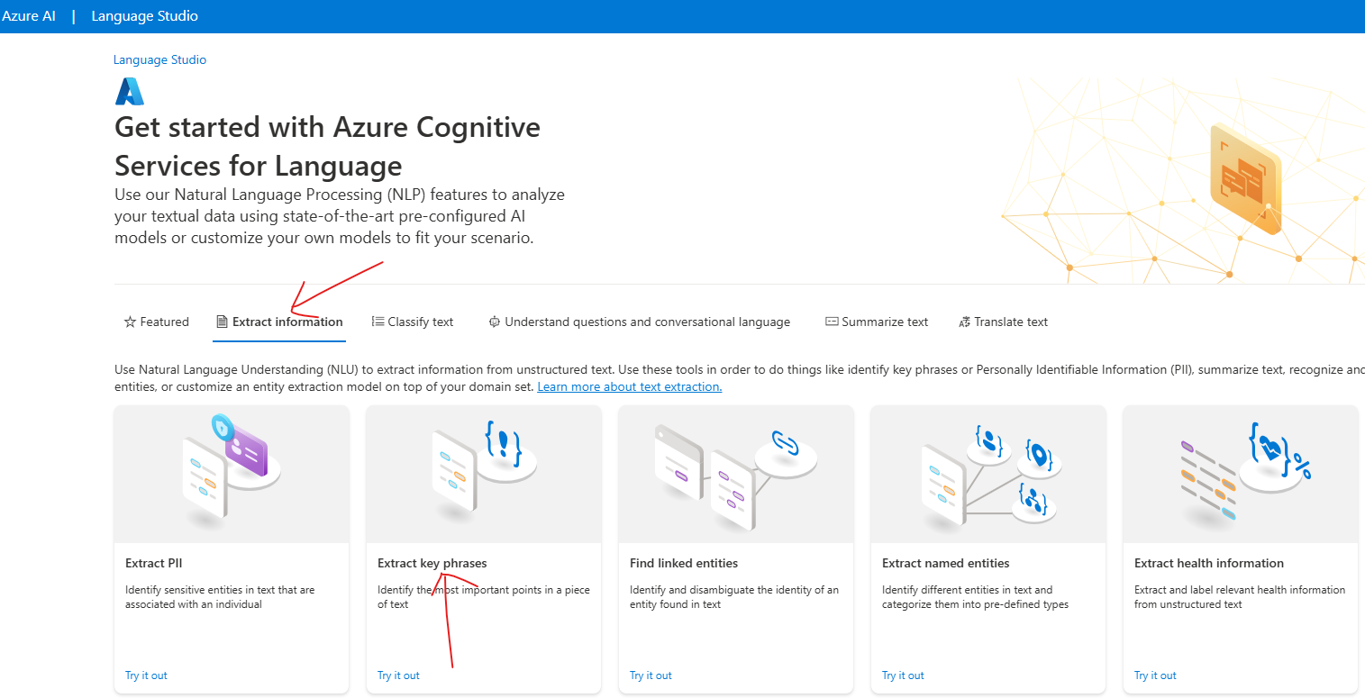

## AZURE TRANSLATOR SERVICE

## AZURE SPEECH SERVICE

# AZURE FOUNDRY

## CREATE AZURE AI HUB

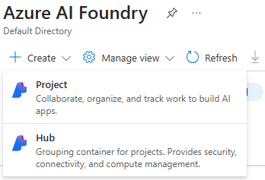

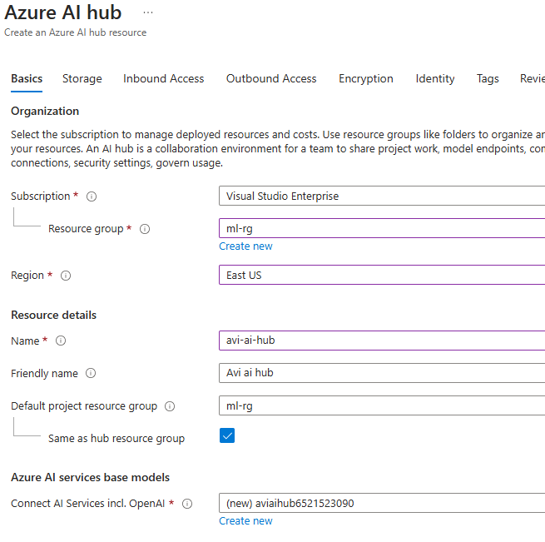

* Keeping others as default 🡪 Create

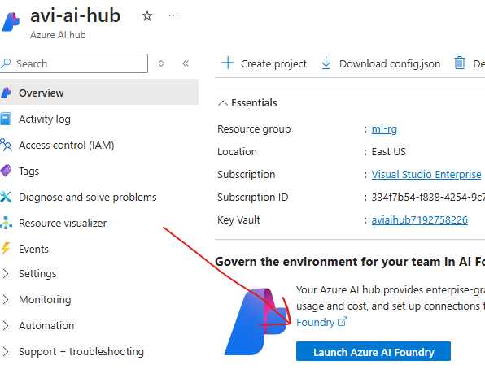

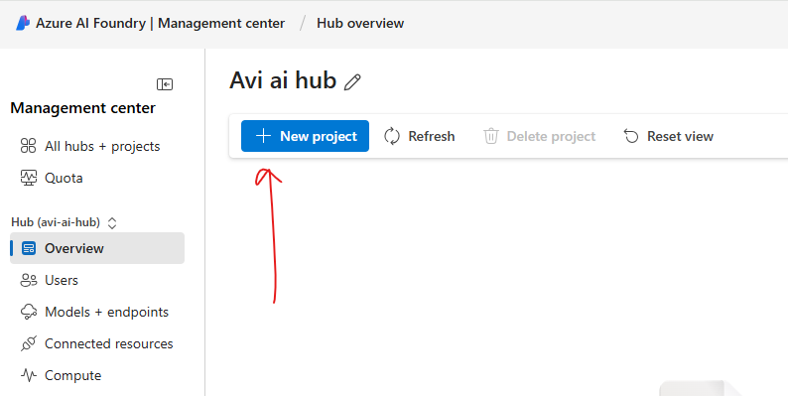

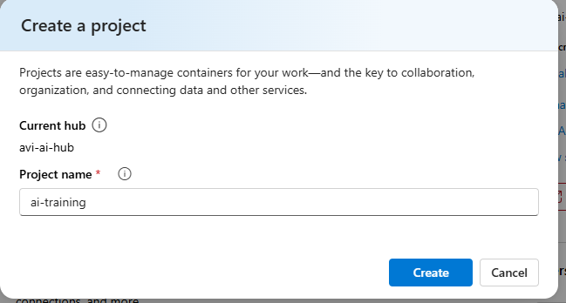

## COURSE RESOURCES AND SET UP

|  |  |
| --- | --- |
|  | 1. Download the course resources 2. Make Sure Python is installed 3. Create a Virtual environment 4. Install “Jupiter” package : **pip install jupyter** 5. Open the jupyter environment using command**: jupyter lab**   *This will open up the jupyter environment a browser window* |

JUPYTER LAB

